Command Reference: RemoveCropPatternTS()

Remove crop pattern time series

StateCU Command
Version 3.09.01, 2010-02-01

The RemoveCropPatternTS() command removes crop pattern time series data. This is useful when inappropriate crop types have been processed into the crop pattern time series (e.g., unirrigated parcels), which may be the case during when using preliminary data. The following dialog is used to edit the command and illustrates the syntax of the command.

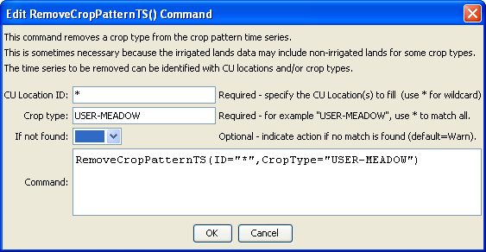
RemoveCropPatternTS
RemoveCropPatternTS() Command Editor

The command syntax is as follows:

RemoveCropPatternTS(Parameter=Value,…)

Command Parameters

Parameter | Description | Default
ID | A single CU Location identifier or pattern to match (e.g., 20*). | None – must be specified.
CropType | A single crop type identifier to match. | None – must be specified.
IfNotFound | Used for error handling, one of the following:  - Fail – generate a failure message if the ID is not matched  - Ignore – ignore (don’t add and don’t generate a message) if the ID is not matched  - Warn – generate a warning message if the ID is not matched | Warn

