Command Reference: RunProgram()
Run an external program

General Command
Version 3.08.02, 2010-01-07

This command is under development. Preliminary development has occurred in the TSTool software. The RunProgram() command runs an external program, given the full command line or individual command line parts, and waits until the program is finished before processing additional commands. The command will indicate a failure if the exit status from the program being run is non-zero. It is therefore possible to call an external program that reads and/or writes recognized time series formats to perform processing that StateDMI cannot. It is also useful to use StateDMI’s testing features to implement quality control checks for other software tools.

StateDMI internally maintains a working directory that is used to convert relative paths to absolute paths to locate files. The working directory is by default the location of the last command file that was opened. The external program may assume that the working directory is the location from which StateDMI software was started (or the installation location if started from a menu). Therefore, it may be necessary to run StateDMI in batch mode from the directory where the external software’s data files exist, use absolute paths to files, or use the ${WorkingDir} property in the command line. Use \” in the command line or arguments to surround whitespace. Some operating systems may have limitations on command line length. The following dialog is used to edit the command and illustrates command syntax.

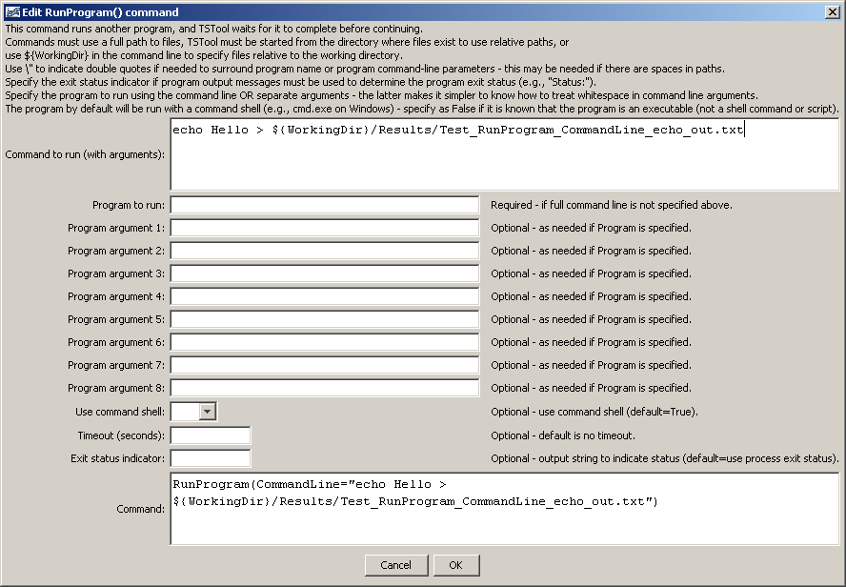
RunProgram
RunProgram() Command Editor when Specifying Command Line
The command syntax is as follows:

RunProgram(Parameter=Value…)

Command Parameters

Parameter | Description | Default
CommandLine | The full program command line, with arguments. If the program executable is found in the PATH environment variable, then only the program name needs to be specified. Otherwise, specify an absolute path to the program or run StateDMI from a command shell the same directory.  The ${WorkingDir} property can be used in the command line to indicate the working directory (command file location) when specifying file names.  For Windows, it may be necessary to place a \” at the start and end of the command line, if a full command line is specified. | Must be specified if the Program parameter is not specified.  The Program parameter will be used if both are specified.
Program | The name of the program to run. Program arguments are specified using the ProgramArg# parameter(s). See the CommandLine parameter for more information about parameter formatting and locating the executable. | Must be specified if the CommandLine parameter is not specified.
ProgramArg1, ProgramArg2, etc. | Command like arguments used with Program. If necessary, use ${WorkingDir} to specify the working directory to locate files. | No arguments will be used with Program.
UseCommandShell | If specified as False, the program will be run without using a command shell. A command shell is needed if the program is a script (batch file), a shell command, or uses >, |, etc. | True, using cmd.exe /C on Windows and /bin/sh –c on UNIX/Linux.
Timeout | The timeout in seconds – if the program has not yet returned, the process will be ended. Zero indicates no timeout. This behavior varies and is being enhanced. | No timeout.
ExitStatus  Indicator | By default, the program exit status is determined from the process that is run. Normally 0 means success and non-zero indicates an error. However, the program may not exit with a non-zero exit status when an error occurs. If the program instead uses an output string like STOP 3 to indicate the status, use this parameter to indicate the leading string, which is followed by the exit status (e.g., STOP). | Determine the exit status from the process exit value.

The following figure illustrates how a command would be entered using the program name and parts, and use the command shell to run. Note that the output redirection character “>” is entered as a program argument. The echo program on Windows is actually internal to the cmd.exe command shell and therefore must be run using the command shell (the default behavior).

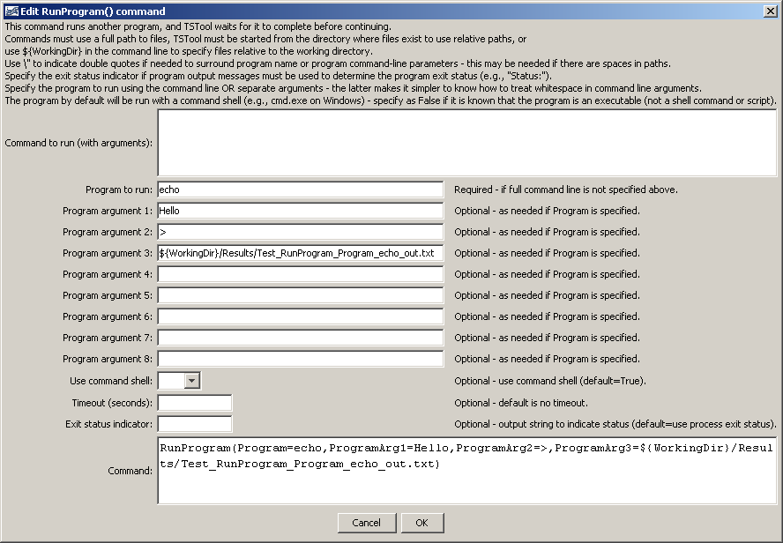
RunProgram_Program
RunProgram() Command Editor when Specifying Program and Arguments

The following figure illustrates how a command can be run without a command shell and using the program output to determine the exit status. The testecho.exe program is a compiled executable and can therefore be run without a command shell. Because the standard output is being evaluated for the exit value, the output cannot be redirected to a file with > (this would result in no output being available to StateDMI to evaluate), and > is only recognized if running with a command shell in any case.

The following approach is suitable, for example, when running a compiled model or data analysis tool. However, if the tool is run using a script or batch file, then a command shell must be used.

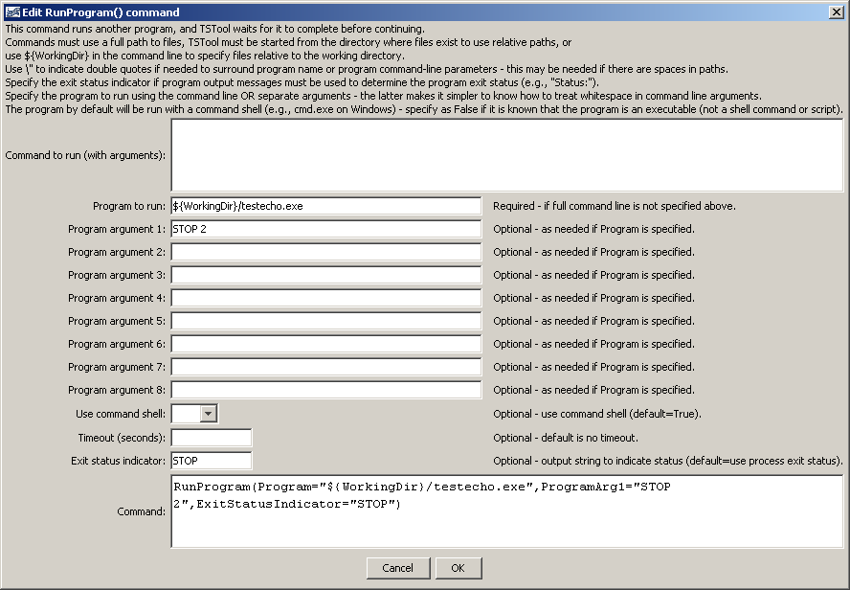
RunProgram_Program_ExitStatusIndicator
RunProgram() Command Editor when Specifying Program, Arguments, and Exit Status Indicator

