Command Reference: SetBlaneyCriddle()

Set Blaney-Criddle crop coefficients data

StateCU Command
Version 3.08.02, 2010-01-07

The SetBlaneyCriddle() command sets data in existing Blaney-Criddle crop coefficients or adds a new crop type with crop coefficients. The following dialog is used to edit the command and illustrates the syntax of the command.

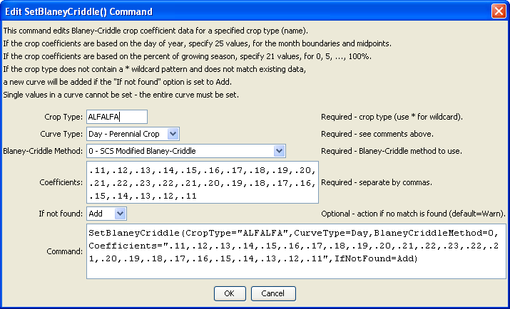
SetBlaneyCriddle
SetBlaneyCriddle() Command Editor

The command syntax is as follows:

SetBlaneyCriddle(Parameter=Value,…)

Command Parameters

Parameter | Description | Default
CropType | A crop type to match or a pattern using wildcards (e.g., ALFALFA*). | None – must be specified.
CurveType | Specify Percent for an annual crop or Day for a perennial crop. | If not specified, the original value will remain.
Coefficients | A list of coefficients, surrounded by double quotes. | If not specified, the original value will remain.
IfNotFound | Used for error handling, one of the following:  - Add – add the crop if not found using the provided information  - Fail – generate a failure message if the crop is not found  - Ignore – ignore (don’t add and don’t generate a message) if the crop is not found  - Warn – generate a warning message if the crop is not found | Warn

