Command Reference: SetCULocation()

Set CU Location data

StateCU Command
Version 3.08.02, 2010-01-02

The SetCULocation() command sets data in existing CU Locations or adds a new CU Location. The following dialog is used to edit the command and illustrates the syntax of the command.

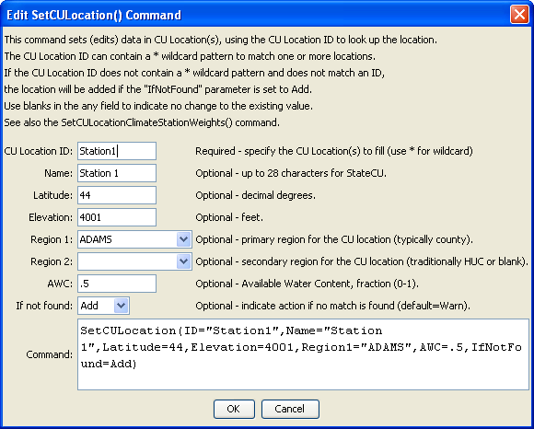
SetCULocation
SetCULocation() Command Editor

The command syntax is as follows:

SetCULocation(Parameter=Value,…)

Command Parameters

Parameter | Description | Default
ID | A single CU Location identifier to match or a pattern using wildcards (e.g., 20*). | None – must be specified.
Latitude | The latitude to be assigned for all matching CU Locations. | If not specified, the original value will remain.
Elevation | The elevation to be assigned for all matching CU Locations. | If not specified, the original value will remain.
Region1 | The Region1 to be assigned for all matching CU Locations. | If not specified, the original value will remain.
Region2 | The Region2 to be assigned for all matching CU Locations. | If not specified, the original value will remain.
Name | The name to be assigned for all matching CU Locations. | If not specified, the original value will remain.
AWC | The available water content (AWC) to be assigned for all matching CU Locations. | If not specified, the original value will remain.
IfNotFound | Used for error handling, one of the following:  - Fail – generate a failure message if the ID pattern is not matched  - Ignore – ignore (don’t generate a message) if the ID pattern is not matched  - Warn – generate a warning message if the ID pattern is not matched | Warn

