Command Reference: setCULocationClimateStationWeightsFromHydroBase()

Set CU Location climate station weights data from HydroBase

StateCU Command
Version 01.07.00, 2004-03-31, Color, Acrobat Distiller

The setCULocationClimateStationWeightsFromHydroBase() command sets climate station weights data in existing CU Locations, using HydroBase for data. The following dialog is used to edit the command and illustrates the syntax of the command.

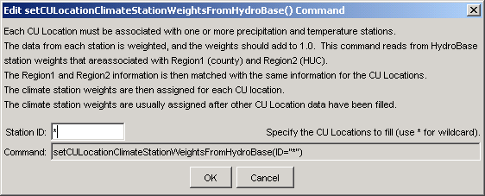
setCULocationClimateStationWeightsFromHydroBase
setCULocationClimateStationWeightsFromHydroBase() Command Editor

The command syntax is as follows:

setCULocationClimateStationWeightsFromHydroBase(param=value,…)

Command Parameters

Parameter | Description | Default
ID | A single CU Location identifier to match or a pattern using wildcards (e.g., 20*). | None – must be specified.

