Command Reference: SetCULocationsFromList()

Set CU Location data from information in a delimited file

StateCU Command
Version 3.08.02, 2010-01-07

The SetCULocationsFromList() command sets data in existing CU Locations by reading information from a delimited file. New locations are not added. The following dialog is used to edit the command and illustrates the syntax of the command.

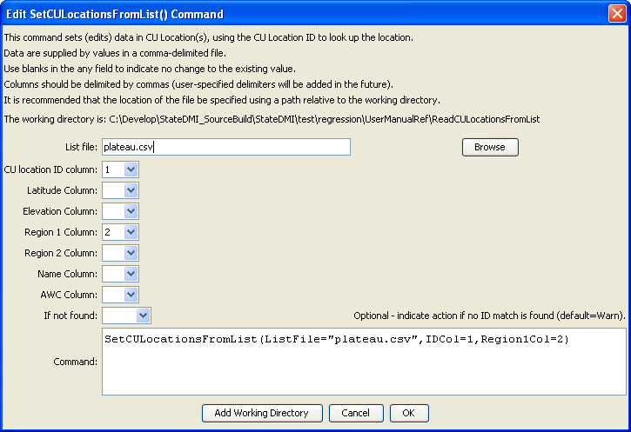
SetCULocationsFromList
SetCULocationsFromList() Command Editor

The command syntax is as follows:

SetCULocationsFromList(Parameter=Value,…)

Command Parameters

Parameter | Description | Default
ListFile | Path to the delimited list file to read. | None – must be specified.
IDCol | The column number (1+) containing the CU Location identifiers. | None – must be specified.
LatitudeCol | The column number (1+) containing the CU Location latitude. | If not specified, the previous value will remain.
ElevationCol | The column number (1+) containing the CU Location elevation. | If not specified, the previous value will remain.
Region1Col | The column number (1+) containing the CU Location Region1. | If not specified, the previous value will remain.
Region2Col | The column number (1+) containing the CU Location Region2. | If not specified, the previous value will remain.
NameCol | The column number (1+) containing the CU Location name. | If not specified, the previous value will remain.
AWCCol | The column number (1+) containing the CU Location AWC. | If not specified, the previous value will remain.
IfNotFound | Used for error handling, one of the following:  - Fail – generate a failure message if the climate station is not found  - Ignore – ignore (don’t add and don’t generate a message) if the climate station is not found  - Warn – generate a warning message if the climate station is not found | Warn

Lines starting with the # character are treated as comments. If the first line’s values are surrounded by double quotes, the line is assumed to indicate column headings.

An example list file is shown below:

72_ADC064,MESA2
72_ADC063,MESA2
72_ARC010,MESA2
950030,MESA2
720766,MESA2
720731,MESA2
720514,MESA2
720933,MESA2
72_ADC062,MESA2
721339,MESA2
720580,MESA2

