Command Reference: SetClimateStation()

Set climate station data

StateCU Command
Version 03.12.00, 2011-01-17

The SetClimateStation() command sets data in existing climate stations or adds a new climate station. The following dialog is used to edit the command and illustrates the syntax of the command.

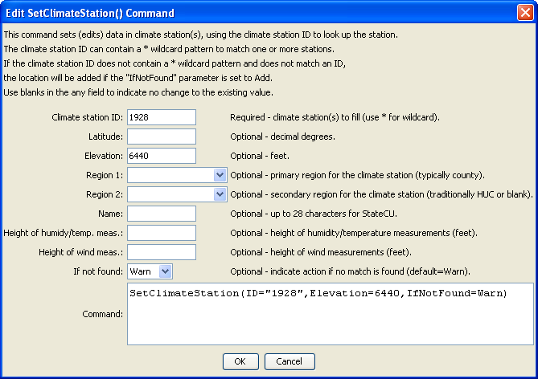
SetClimateStation
SetClimateStation() Command Editor

The command syntax is as follows:

SetClimateStation(Parameter=Value,…)

Command Parameters

Parameter | Description | Default
ID | A single climate station identifier to match or a pattern using wildcards (e.g., 20*). | None – must be specified.
Latitude | The climate station latitude to be assigned for all matching climate stations. | If not specified, the original value will remain.
Elevation | The climate station elevation to be assigned for all matching climate stations. | If not specified, the original value will remain.
Region1 | The climate station Region1 (typically county) to be assigned for all matching climate stations. | If not specified, the original value will remain.
Region2 | The climate station Region2 (typically the HUC basin) to be assigned for all matching climate stations. | If not specified, the original value will remain.
Name | The climate station name to be assigned for all matching climate stations. | If not specified, the original value will remain.
HeightHumidity  Meas | The height of humidity and temperature measurements (feet), only used with daily analysis. | If not specified, the original value will remain.
HeightWindMeas | The height of wind measurements (feet), only used with daily analysis. | If not specified, the original value will remain.
IfNotFound | Used for error handling, one of the following:  - Add – add the climate station if the ID is not matched and is not a wildcard  - Fail – generate a failure message if the ID is not matched  - Ignore – ignore (don’t add and don’t generate a message) if the ID is not matched  - Warn – generate a warning message if the ID is not matched | Warn

The following example command file illustrates how climate stations can be defined and written to a StateCU file:

ReadClimateStationsFromList(ListFile="climsta.lst",IDCol=1)
FillClimateStationsFromHydroBase(ID="*")
SetClimateStation(ID="3016",Region2="14080106",IfNotFound=Warn)
SetClimateStation(ID="1018",Region2="14040106",IfNotFound=Warn)
SetClimateStation(ID="1928",Elevation=6440,IfNotFound=Warn)
SetClimateStation(ID="0484",Region1="MOFFAT",IfNotFound=Add)
WriteClimateStationsToStateCU(OutputFile="COclim2006.cli")

