Command Reference: SetCropCharacteristics()
Set crop characteristics data

StateCU Command
Version 3.08.02, 2010-01-07

The SetCropCharacteristics() command sets data in existing crop characteristics or adds a new crop type with crop characteristics. The following dialog is used to edit the command and illustrates the syntax of the command.

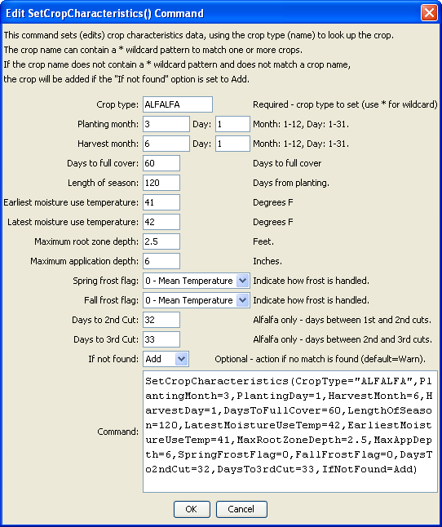
SetCropCharacteristics
SetCropCharacteristics() Command Editor
The command syntax is as follows:

SetCropCharacteristics(Parameter=Value,…)

Command Parameters

Parameter | Description | Default
CropType | A crop type to match or a pattern using wildcards (e.g., ALFALFA*). | None – must be specified.
PlantingMonth | The planting month for the crop, as an integer (1=January). | If not specified, the original value will remain.
PlantingDay | The planting day of month for the crop, for the planning month. | If not specified, the original value will remain.
HarvestMonth | The harvest month for the crop, as an integer (1=January). | If not specified, the original value will remain.
HarvestDay | The harvest day of month for the crop, for the planning month. | If not specified, the original value will remain.
DaysToFullCover | Days to full cover. | If not specified, the original value will remain.
LengthOfSeason | Length of growing season, days. | If not specified, the original value will remain.
EarliestMoistureUseTemp | Earliest moisture use temperature, F. | If not specified, the original value will remain.
LatestMoistureUseTemp | Latest moisture use temperature, F. | If not specified, the original value will remain.
MaxRootZoneDepth | Maximum root zone depth. | If not specified, the original value will remain.
MaxAppDepth | Maximum application depth. | If not specified, the original value will remain.
SpringFrostFlag | Spring frost flag. | 0 (mean)
FallFrostFlag | Fall frost flag. | 0 (mean)
DaysTo2ndCut | Days between first and second cuts (alfalfa). | If not specified, the original value will remain.
DaysTo3rdCut | Days between second and third cuts (alfalfa). | If not specified, the original value will remain.
IfNotFound | Used for error handling, one of the following:  - Add – add the climate station if not found using the provided information  - Fail – generate a failure message if the climate station is not found  - Ignore – ignore (don’t add and don’t generate a message) if the climate station is not found  - Warn – generate a warning message if the climate station is not found | Warn

