Command Reference: SetCropPatternTS()

Set crop pattern time series values

StateCU Command
Version 3.09.01, 2010-02-01

The SetCropPatternTS() command sets crop pattern time series data for a CU Location. The combination of location ID, crop type, and year identify the data. It is recommended that the SetCropPatternTSFromList() command be used instead to shorten commands files and allow sharing of the data with SetIrrigationPracticeTSFromList() commands. There are two uses for this command:

- Specify crop data for a location, to be processed with parcel data. For example, an irrigated lands assessment using GIS might show zero acreage for a ditch but other information indicates that the ditch irrigates lands. The ditch may be an individual (key) structure or may be part of an aggregate/system. In this case, the specified data values contribute to the final data values in output. The following dialog is used to edit the command and illustrates the syntax of the command. The years typically agree with an irrigated lands assessment and the Process when value must be specified as WithParcels. In this case, the SetCropPatternTS() commands should be specified before ReadCropPatternTSFromHydroBase() or other similar commands. The data will be processed as if they were read from HydroBase.

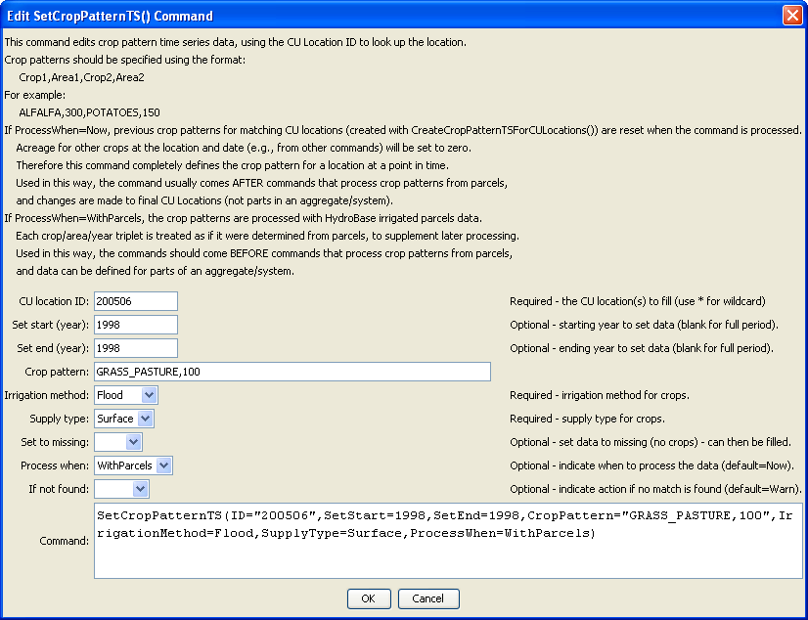
SetCropPatternTS_WithParcels
SetCropPatternTS() Command Editor (to specify parcel information)

- Specify crop data to override (or supply) crop pattern data for a structure. In this case, the specified data will be visible as the final data values in output and will not be considered when irrigated lands parcels are processed. The Process when flag should be blank or Now. In this case, the SetCropPatternTS() commands should be specified after ReadCropPatternTSFromHydroBase() or other similar commands. It is recommended that the previous alternative be used, in particular when multiple years of data are being processed and need to be quality controlled.

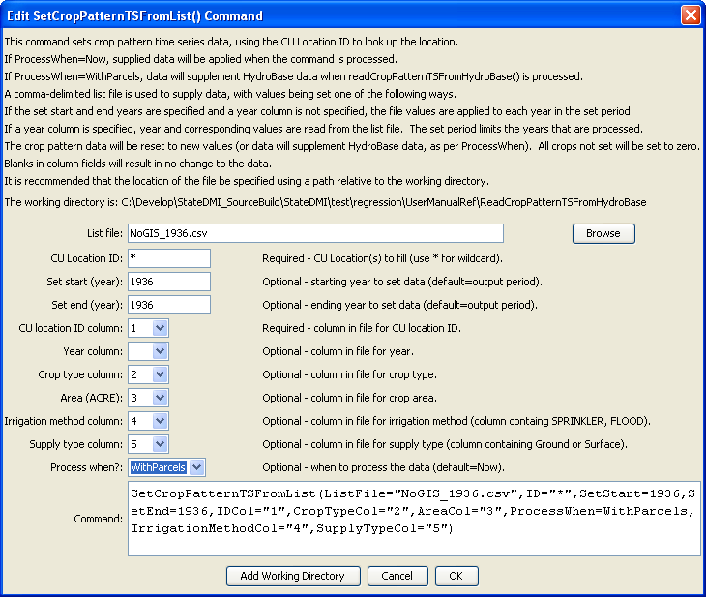
SetCropPatternTS
SetCropPatternTS() Command Editor (to edit crop pattern time series)

The command syntax is as follows:

SetCropPatternTS(Parameter=Value,…)

Command Parameters

Parameter | Description | Default
ID | A single CU Location identifier to match or a pattern using wildcards (e.g., 20*). | None – must be specified.
SetStart | The first year to set data values. | If not specified, data are set for the full output period.
SetEnd | The last year to set data values. | If not specified, data are set for the full output period.
CropPattern | A sequence of crop type and area values, to set as data for the specified period. | None – must be specified.
SetStart | Starting year to set data. | Set for the full period.
SetEnd | Ending year to set data. | Set for the full period.
SetToMissing | Indicate whether the crop pattern for the specified years should be set to missing, instead of supplying data values. This was used in the Río Grande as follows: Read 1936, 1998, and 2002 data, resulting in crop pattern time series. It is necessary to include all years in order to get a complete list of crops over the period, even if zero or missing in some years. After reading all years, 2002 is set to missing using this command and a standard filling approach is used for the full period. Then, 2002 is read at the end. The overall result is that 2002’s crops are listed in the full period but only have non-zero observations in 2002. | False
ProcessWhen | Indicates when the specified data values should be processed. If the parameter value is WithParcels, then the values will be considered when irrigated lands data are processed with later ReadCropPatternTSFromHydroBase(). | Now, indicating that the acreage should be set when the command is processed (not when later read commands are processed).
IfNotFound | Used for error handling, one of the following:  - Fail – generate a failure message if the ID is not matched  - Ignore – ignore (don’t add and don’t generate a message) if the ID is not matched  - Warn – generate a warning message if the ID is not matched | Warn

