Command Reference: SetDebugLevel()
Set Level for Debug Messages

General Command
Version 3.08.02, 2010-01-06

The SetDebugLevel() command is used to set debug levels for the screen and log file. The following dialog is used to edit this command and illustrates the command syntax.

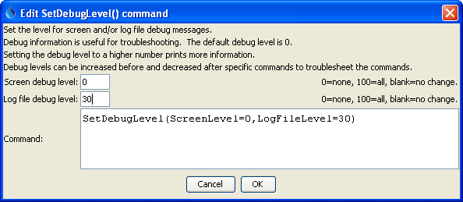
SetDebugLevel
SetDebugLevel() Command Editor

Debug messages are useful during troubleshooting. A general guideline is that a debug level of 1 prints basic messages, 30 prints detailed information about processing, and 100 prints very low-level messages about input/output. Intermediate values will result in more or less output.

This command is useful for troubleshooting and can be specified multiple times to increase debug output for a specific command, if necessary.

This page is intentionally blank.

