Command Reference: SetDiversionMultiStructFromList()

Set diversion MultiStruct parts from data in a list file

StateCU and StateMod Command
Version 3.09.01, 2010-02-01

The SetDiversionMultiStructFromList() command reads diversion MultiStruct part identifier data from a list file and saves the information for the diversion (a CU Location or StateMod diversion station). A diversion MultiStruct indicates that multiple diversion stations take water from more than one tributary but irrigate the same lands. Each diversion station is included in the model network and retains its normal capacity and historical diversions; however, average efficiencies are calculated using the combined demand and historical diversion time series. The demands for the primary structure (the first listed) are set to the total demands, with demands for secondary stations being set to zero. Diversion MultiStruct definition commands are required only when processing the demand time series. The following dialog is used to edit the command and illustrates the syntax of the command.

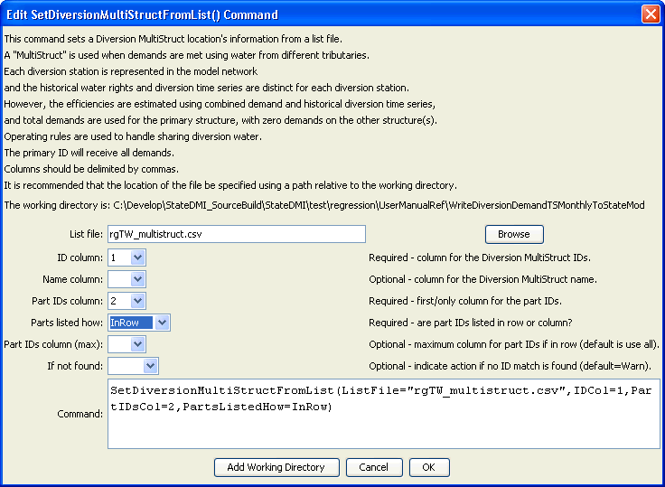
SetDiversionMultiStructFromList
SetDiversionMultiStructFromList() Command Editor

The command syntax is as follows:

SetDiversionMultiStructFromList(Parameter=Value,…)

Command Parameters

Parameter | Description | Default
ListFile | The name of the input file to read, surrounded by double quotes. | None – must be specified.
IDCol | The column number (1+) containing the diversion MultiStruct primary station identifiers. | None – must be specified.
NameCol | The column number (1+) containing the diversion MultiStruct name. | None – optional (if not specified the name will not be changed).
PartIDsCol | The column number (1+) for the first column having part identifiers. | None – must be specified.
PartIDsColMax | The column number (1+) for the last column having part identifiers. | Use all available columns.
PartsListedHow | If InRow, it is expected that all parts defining a system are listed in the same row. If InColumn, it is expected that the parts defining a system are listed one per row, with multiple rows defining the full system (PartIDsColMax is ignored in this case). | None – must be specified.
IfNotFound | Used for error handling, one of the following:  - Fail – generate a failure message if the MultiStruct identifier is not matched  - Ignore – ignore (don’t add and don’t generate a message) if the aggregate identifier is not matched  - Warn – generate a warning message if the aggregate identifier is not matched | Warn

An example list file is shown below:

#AggID,Ditch,Ditch,Ditch,Ditch,Ditch,Ditch,Ditch,Ditch,Ditch,Ditch,Ditch,
20MS01,200516,200613,201004
20MS02,200623,201060,210521,210522
20MS03,200706,200784
20MS04,200814,200815
20MS05,200683,200775
…

