Command Reference: SetDiversionRight()

Set diversion right data

StateCU and StateMod Command
Version 3.09.00, 2010-01-26

The SetDiversionRight() command sets data in existing diversion rights or adds a new diversion right. If a new right is added, it is added in alphabetical order according to the right identifier. The following dialog is used to edit the command and illustrates the syntax of the command.

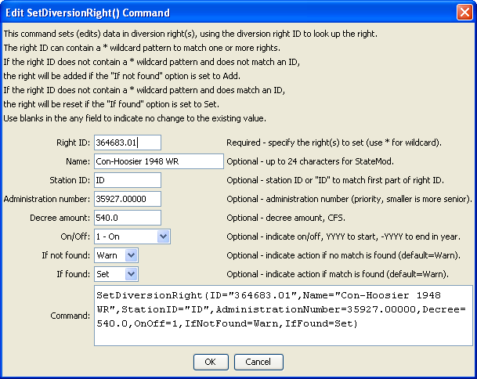
SetDiversionRight
SetDiversionRight() Command Editor

The command syntax is as follows:

SetDiversionRight(Parameter=Value,…)

Command Parameters

Parameter | Description | Default
ID | A single diversion right identifier to match or a pattern using wildcards (e.g., 20*). | None – must be specified.
Name | The name to be assigned for all matching diversion rights. | If not specified, the original value will remain.
StationID | The diversion station identifier to be assigned for all matching diversion rights. | If not specified, the original value will remain.
AdministrationNumber | The administration number to be assigned for all matching diversion rights. | If not specified, the original value will remain.
Decree | The water right decree to be assigned for all matching diversion rights. | If not specified, the original value will remain.
OnOff | The on/off switch value to be assigned for all matching diversion rights, either 1 for on or 0 for off, a positive 4-digit year to turn the right on starting in the year, or a negative 4-digit year to turn the right off starting in the year. | If not specified, the original value will remain.
IfNotFound | Used for error handling, one of the following:  - Add – add the water right if the ID is not matched and is not a wildcard  - Fail – generate a failure message if the ID is not matched  - Ignore – ignore (don’t add and don’t generate a message) if the ID is not matched  - Warn – generate a warning message if the ID is not matched | Warn
IfFound | Used for error handling, one of the following:  - Set – set the water right data  - Fail – generate a failure message if the ID is matched  - Ignore – ignore (don’t set and don’t generate a message) if the ID is matched  - Warn – generate a warning message if the ID is matched | Warn

