Command Reference: SetDiversionStationDelayTablesFromNetwork()

Set diversion station delay table data from the network

StateMod Command
Version 3.09.01, 2010-02-01

The SetDiversionStationDelayTablesFromNetwork() command sets delay table data in existing diversion stations using network information. A default delay table is used to assign 100% of the returns to the downstream node in the network. This command is often used to set a default before more specific delay table information is set with the SetDiversionStationDelayTablesFromRTN() command. The following dialog is used to edit the command and illustrates the syntax of the command.

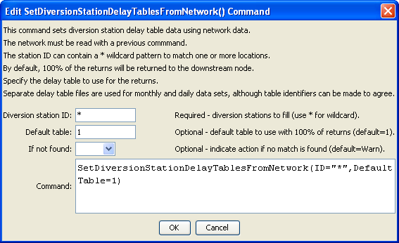
SetDiversionStationDelayTablesFromNetwork
SetDiversionStationDelayTablesFromNetwork() Command Editor

The command syntax is as follows:

SetDiversionStationDelayTablesFromNetwork(Parameter=Value,…)

Command Parameters

Parameter | Description | Default
ID | A single diversion station identifier to match or a pattern using wildcards (e.g., 20*). | None – must be specified.
DefaultTable | The default delay table to use when assigning the delay tables. | None – must be specified.
IfNotFound | Used for error handling, one of the following:  - Fail – generate a failure message if the ID is not matched  - Ignore – ignore (don’t add and don’t generate a message) if the ID is not matched  - Warn – generate a warning message if the ID is not matched | Warn

