Command Reference: SetDiversionStationDelayTablesFromRTN()

Set diversion station delay table data from an RTN format file

StateMod Command
Version 3.09.01, 2010-02-01

The SetDiversionStationDelayTableFromRTN() command sets delay table data in existing diversion stations using information in an RTN format file, which is a format that has been used in CDSS StateMod modeling, and is created by the “makertn” program. The following dialog is used to edit the command and illustrates the syntax of the command.

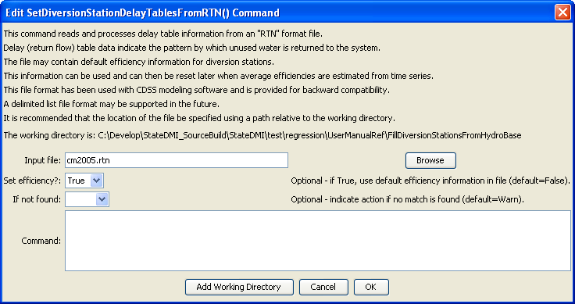
SetDiversionStationDelayTablesFromRTN
SetDiversionStationDelayTablesFromRTN() Command Editor

The command syntax is as follows:

SetDiversionStationDelayTablesFromRTN(Parameter=Value,…)

Command Parameters

Parameter | Description | Default
InputFile | The name of the RTN file to process. Specify an absolute path or a path relative to the working directory. | None – must be specified.
SetEfficiency | Indicates whether the default efficiency value in the file should be used. | None – must be specified.
IfNotFound | Used for error handling, one of the following:  - Fail – generate a failure message if the ID is not matched  - Ignore – ignore (don’t add and don’t generate a message) if the ID is not matched  - Warn – generate a warning message if the ID is not matched | Warn

A sample RTN file is shown below:

200511 2 75 1
200742 1 1
200742 99 2
200742 2 75 1
200787 1 1
200787 99 2
200752 2 75 1
20ADW07 1 1
20ADW07 99 2

The first line contains the station identifier, number of return flow locations, default efficiency for the station, and the default delay table to use for the return. For the number of return flow locations, the following lines indicate the identifier for the station to receive the return, the percentage of the return to receive, and the delay table for the return.

