Command Reference: SetDiversionStationsFromList()

Set diversion station data from a list file

StateMod Command
Version 3.09.01, 2010-02-01

The SetDiversionStationsFromList() command sets data in existing diversion stations (it currently will not add a station – use ReadDiversionStationsFromList()). This command is useful when data has been created from another program or process. The following dialog is used to edit the command and illustrates the syntax of the command.

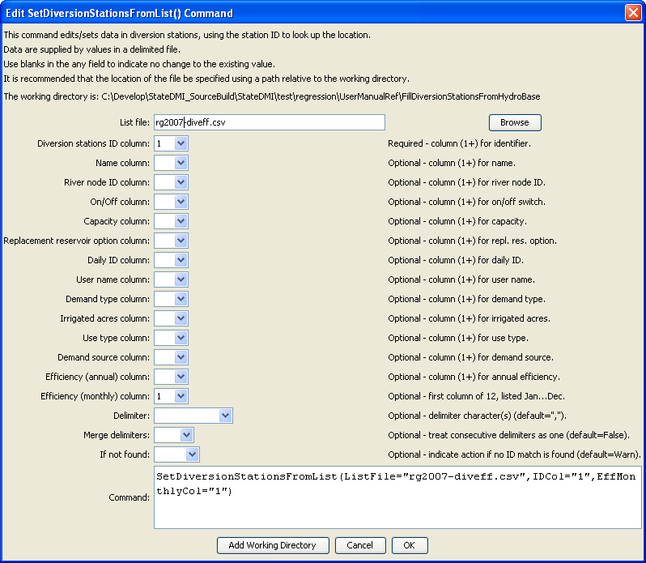
SetDiversionStationsFromList
SetDiversionStationsFromList() Command Editor

The command syntax is as follows:

SetDiversionStationsFromList(Parameter=Value,…)

Command Parameters

Parameter | Description | Default
ListFile | The name of the delimited input file to read. Strings that include delimiter characters can be surrounded by double quotes in the list file. Lines starting with # are treated as comments. | None – must be specified.
IDCol | The column number (1+) containing the diversion station identifiers. | If not specified, the original value will remain.
NameCol | The column number (1+) containing the diversion station names. | If not specified, the original value will remain.
RiverNodeIDCol | The column number (1+) containing the river node identifiers. | If not specified, the original value will remain.
OnOffCol | The column number (1+) containing the on/off switch. | If not specified, the original value will remain.
CapacityCol | The column number (1+) containing the capacity. | If not specified, the original value will remain.
ReplaceResOptionCol | The column number (1+) containing the replacement reservoir option. | If not specified, the original value will remain.
DailyIDCol | The column number (1+) containing the daily identifier. | If not specified, the original value will remain.
UserNameCol | The column number (1+) containing the user name. | If not specified, the original value will remain.
DemandTypeCol | The column number (1+) containing the demand type. | If not specified, the original value will remain.
IrrigatedAcresCol | The column number (1+) containing the irrigated acres. | If not specified, the original value will remain.
UseTypeCol | The column number (1+) containing the use type. | If not specified, the original value will remain.
DemandSourceCol | The column number (1+) containing the demand source. | If not specified, the original value will remain.
EffAnnualCol | The column number (1+) containing the annual efficiency. If the annual efficiency is specified, each monthly efficiency will be set to the annual value. | If not specified, the original value will remain.
EffMonthlyCol | The column number (1+) containing the monthly efficiency for January. The efficiencies for other months should be specified in columns that follow. The annual efficiency is set to the average of the monthly efficiencies. The efficiencies in the list file must be listed January to December as percent (0 to 100). The order of the values in the StateMod diversion stations will be according to the output year type set by setOutputYearType(), or calendar by default. | If not specified, the original values will remain.
Delim | The character(s) that delimits columns, or one of the literal words:  - Space  - Tab  - Whitespace – spaces and tabs. | , (comma)
MergeDelim | If True, then treat consecutive delimiter characters as one delimiter. If False, separate columns will result. | False
IfNotFound | Used for error handling, one of the following:  - Fail – generate a failure message if the ID is not matched  - Ignore – ignore (don’t add and don’t generate a message) if the ID is not matched  - Warn – generate a warning message if the ID is not matched | Warn

The following example illustrates how to create diversion stations from a list file and then set the efficiencies (in this case from a StateCU output file) from another list. The full data line is trimmed of whitespace before processing and data in columns are automatically trimmed of whitespace after parsing.

StartLog(LogFile="commands.StateDMI.log")
# For testing...
# setOutputYearType(Water)
ReadDiversionStationsFromList(ListFile="rgdssall.csv",IDCol="1")
SetDiversionStationsFromList(
ListFile="rg2007-diveff.csv",IDCol="1",
EffMonthlyCol="2",Delim="Space",MergeDelim=True,IfNotFound=Warn)
WriteDiversionStationsToStateMod(OutputFile="rgdssall.dds")

The following is an example of the list file used with the above:

# Card 1 Control
# format: (Free)
# NOTE EFF1 IS JANUARY, EFF2 IS FEBRUARY, ETC.
#
# ID cwelid: Well ID
# Eff1 eff(1) Efficiency in month 1
# Eff1 eff(2) Efficiency in month 2
# ... .... ...
# Eff1 eff(12) Efficiency in month 12
#
#
#1 ID Eff1 Eff2 Eff3 Eff4 Eff5 Eff6'Eff7 Eff8 Eff9 Eff10 Eff11 Eff12
#----------eb------eb------eb------eb------eb------eb------eb---'---eb------eb------eb------eb------eb------exb----------eb-----
#
200505 42. 42. 42. 42. 42. 42. 42. 42. 42. 42. 42. 42. ALAMOSA D
200511 49. 49. 14. 8. 21. 30. 38. 35. 27. 11. 3. 4. ANACONDA D

