Command Reference: SetDiversionSystem()

Set diversion system parts

StateCU and StateMod Command
Version 3.08.02, 2010-01-07

The SetDiversionSystem() command sets diversion system part identifier data for a diversion (a CU Location that corresponds to a diversion or D&W node or StateMod diversion station). Diversion systems are specified using a list of ditch identifiers, and the system information applies for the full model period (does not vary by year). To facilitate processing, it is often best to use list files to specific systems (see SetDiversionSystemFromList()). Systems by convention have their water rights fully represented in output – to aggregate water rights at a location, use an aggregate (see the similar Aggregate commands). See also the StateDMI Introduction chapter, which provides additional information about systems and other modeling conventions. System information should be specified after diversion locations are defined and before their use in other processing, such as reading data from HydroBase.

The following dialog is used to edit the command and illustrates the syntax of the command.

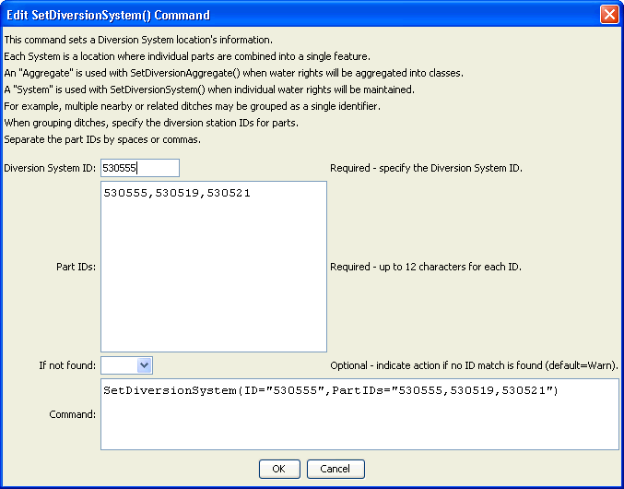
SetDiversionSystem
SetDiversionSystem() Command Editor
The command syntax is as follows:

SetDiversionSystem(Parameter=Value,…)

Command Parameters

Parameter | Description | Default
ID | The diversion identifier to associate with the collection of individual diversions. | None – must be specified.
PartIDs | The list of part identifiers to comprise the system, for example ditch WDIDs that will be found in HydroBase. The part identifiers are by default of type Ditch. | None – must be specified.
IfNotFound | Used for error handling, one of the following:  - Fail – generate a failure message if the identifier is not matched  - Ignore – ignore (don’t add and don’t generate a message) if the identifier is not matched  - Warn – generate a warning message if the identifier is not matched | Warn

