Command Reference: SetInstreamFlowDemandTSAverageMonthlyConstant()

Set instream flow demand time series (average monthly) data to constant value(s)

StateMod Command
Version 3.09.01, 2010-02-02

The SetInstreamFlowDemandTSAveragMonthlyConstant() command sets instream flow demand time series (average monthly) data to constant monthly values. Typically this command is used to (re)set values after the SetInstreamFlowDemandTSAveragMonthlyFromRights() command is used.

The following dialog is used to edit the command and illustrates the syntax of the command.

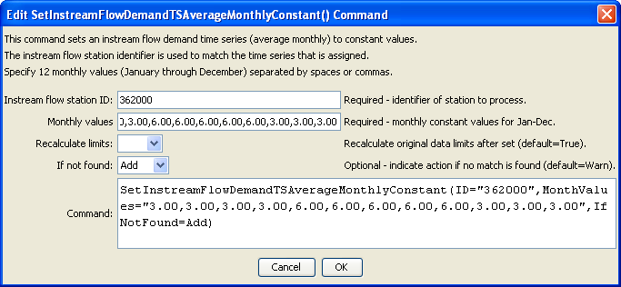
SetInstreamFlowDemandTSAverageMonthlyConstant
SetInstreamFlowDemandTSAverageMonthlyConstant() Command Editor

The command syntax is as follows:

SetInstreamFlowDemandTSAverageMonthlyConstant(Parameter=Value,…)

Command Parameters

Parameter | Description | Default
ID | A single instream flow station identifier to match or a pattern using wildcards (e.g., 20*). | None – must be specified.
MonthValues | Twelve monthly instream flow demand time series values for January through December. | None – must be specified.
RecalcLimits | If True, then the time series average limits will be recalculated. If False, the limits from previously set data will be used (not typically used). | True
IfNotFound | Used for error handling, one of the following:  - Add – add the instream flow demand time series if the ID is not matched and is not a wildcard  - Fail – generate a failure message if the ID is not matched  - Ignore – ignore (don’t add and don’t generate a message) if the ID is not matched  - Warn – generate a warning message if the ID is not matched | Warn

