Command Reference: SetInstreamFlowRight()

Set instream flow right data

StateMod Command
Version 3.09.01, 2010-03-14, Color, Acrobat Distiller

The SetInstreamFlowRight() command sets data in existing instream flow rights or adds a new instream flow right. If a new right is added, it is added in alphabetical order according to the right identifier. Instream flow rights may be defined for a variety of reasons for modeling purposes where a flow needs to be ensured.

The following dialog is used to edit the command and illustrates the syntax of the command.

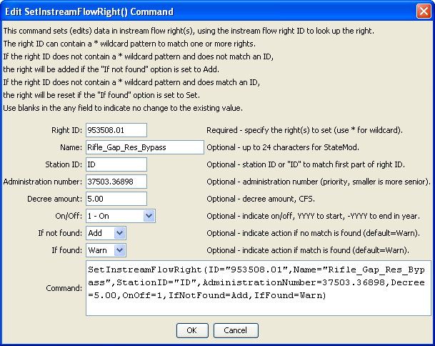
SetInstreamFlowRight
SetInstreamFlowRight() Command Editor

The command syntax is as follows:

SetInstreamFlowRight(Parameter=Value,…)

Command Parameters

Parameter | Description | Default
ID | A single instream flow right identifier to match or a pattern using wildcards (e.g., 20*). | None – must be specified.
Name | The name to be assigned for all matching instream flow rights. | If not specified, the original value will remain.
StationID | The instream flow station identifier to be assigned for all matching instream flow rights. | If not specified, the original value will remain.
Administration  Number | The administration number to be assigned for all matching instream flow rights. | If not specified, the original value will remain.
Decree | The water right decree to be assigned for all matching instream flow rights. | If not specified, the original value will remain.
OnOff | The on/off switch value to be assigned for all matching instream flow rights, either 1 for on or 0 for off, a positive 4-digit year to turn the right on starting in the year, or a negative 4-digit year to turn the right off starting in the year. | If not specified, the original value will remain.
IfNotFound | Used for error handling, one of the following:  - Add – add the instream flow right if the ID is not matched and is not a wildcard  - Fail – generate a failure message if the ID is not matched  - Ignore – ignore (don’t add and don’t generate a message) if the ID is not matched  - Warn – generate a warning message if the ID is not matched | Warn
IfFound | Used for error handling, one of the following:  - Set – set the instream flow right, overwriting previous values if the ID is matched  - Fail – generate a failure message if the ID is matched  - Ignore – ignore (don’t add and don’t generate a message) if the ID is matched  - Warn – generate a warning message if the ID is matched | Warn

