Command Reference: SetInstreamFlowStation()

Set instream flow station data

StateMod Command
Version 3.09.01, 2010-02-01

The SetInstreamFlowStation() command sets data in existing instream flow stations or adds a new instream flow station. The following dialog is used to edit the command and illustrates the syntax of the command.

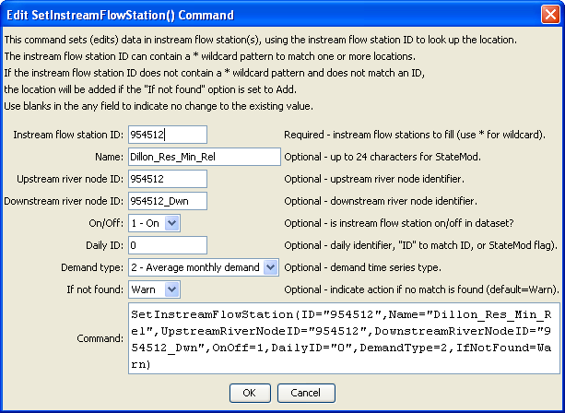
SetInstreamFlowStation
SetInstreamFlowStation() Command Editor

The command syntax is as follows:

SetInstreamFlowStation(Parameter=Value,…)

Command Parameters

Parameter | Description | Default
ID | A single instream flow station identifier to match or a pattern using wildcards (e.g., 20*). | None – must be specified.
Name | The name to be assigned for all matching instream flow stations. | If not specified, the original value will remain.
UpstreamRiverNodeID | The upstream river node identifier to be assigned for all matching instream flow stations. | If not specified, the original value will remain.
DownstreamRiverNodeID | The downstream river node identifier to be assigned for all matching instream flow stations. | If not specified, the original value will remain.
OnOff | The on/off switch value to be assigned for all matching instream flow stations, either 1 for on or 0 for off. | If not specified, the original value will remain.
DailyID | The daily identifier to be assigned for all matching instream flow stations. | If not specified, the original value will remain.
DemandType | The demand type to be assigned for all matching instream flow stations, one of:  1 – Average monthly demand,  2 – Monthly demand. | If not specified, the original value will remain.
IfNotFound | Used for error handling, one of the following:  - Add – add the instream flow station if the ID is not matched and is not a wildcard  - Fail – generate a failure message if the ID is not matched  - Ignore – ignore (don’t add and don’t generate a message) if the ID is not matched  - Warn – generate a warning message if the ID is not matched | Warn

