Command Reference: setIrrigationPracticeTSFromHydroBase()

Set irrigation practice time series (yearly) from HydroBase

StateMod Command
Version 02.14.00, 2007-07-03, Color, Acrobat Distiller

THIS COMMAND IS OBSOLETE – INSTEAD, USE THE readIrrigationPracticeTSFromHydroBase() COMMAND. This older command was used for Phase 4 Río Grande work, and only works with one year of parcel data (e.g., 1998). However, an entirely new procedure has now been implemented, which can be applied to all basins. The new procedure relies on processing water rights into a StateMod water rights file and then using this file as input when processing parcels for the irrigation practice time series. Other commands have also been implemented to allow more control over acreage processing.

The setIrrigationPracticeTSFromHydroBase() command uses data in HydroBase to set the following irrigation practice time series (yearly) information for CU locations:

For each year of parcel data that is available, sprinkler acres for each location are set as the total of the parcel areas that are irrigated using the SPRINKLER irrigation type. Parcels associated with ditches have an area that is adjusted by the ditch coverage percent. All parcels associated with a CU location are used to determine the total sprinkler acres for the CU location. The sprinkler acres can be different for each year that parcels are available in HydroBase. Additional years of sprinkler data can be added using the readIrrigationPracticeTSSprinklerAreaFromList() command. The resulting data points can be used to fill the remaining period (e.g., see fillIrrigationPracticeTS*() commands).
- The well water rights/permits associated with parcels are used to determine the earliest appropriation date associated with each parcel. The groundwater acres value for the parcel is then recognized from the earliest date forward in time, with the earlier period being set to zero. Note that HydroBase data does not allow for turning off wells during the period – the wells currently in HydroBase are assumed to be active from the appropriation/permit date until the current time. Parcels associated with ditches have an area that is adjusted by the ditch coverage percent. All parcels associated with a CU location are used to determine the total groundwater acres for the CU location. If multiple years of parcel data are in HydroBase, the last year to be processed will be in effect after the command is run. Therefore, the well rights/permits will be associated with the most recent year of parcel data. Additional development is necessary to evaluate how to merge multiple years of data.
- Maximum well pumping is NOT processed by this command. However, the water rights resulting from the previous step are kept in memory and can be used by the setIrrigationPracticeTSMaxPumpingToRights() command. Separate commands are used in order to separate processing logic and minimize the command parameters necessary for each step. This also emphasizes the fact that the maximum pumping depends on water rights from the previous step. Therefore, the issue with handling multiple years of parcel data, if resolved in the previous step, will also cascade to the maximum pumping data.

The processing is very similar to that of the readWellRightsFromHydroBase() command, except that a list of CU locations is processed instead a list of StateMod well stations.

The following figure illustrates possible water supply for parcels.

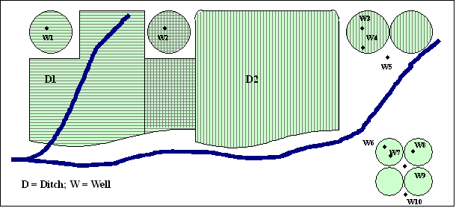
ParcelSupplyDiagram
Example Supply for Parcels

In this example, two ditches (D1 and D2, each represented with different cross-hatching) provide surface water supply to the indicated parcels. In some cases, only one ditch provides supply. Between the ditches, both supply water to shared parcels. Wells can supplement surface water supply (parcels above the river) or can be the sole supplier of water (lower right) and wells do not need to be physically located on a parcel to provide supply to the parcel. For StateCU, well-only lands are identified by CU locations that are defined by a collection (aggregate/system) of parcels. For StateMod, well-only lands are well stations that do not have a related diversion station. In both cases, lands irrigated by surface water are identified with ditch identifiers and parcels are associated to the ditches in HydroBase. Typically, well-only lands are grouped and multiple wells provide supply to the collection of parcels. Processing logic is different for ditch and well-only lands.

A well (hole in the ground) in HydroBase can be either a structure with water rights, a well permit, or both. In HydroBase, the relationship between well structure and well permit has been determined in CDSS projects by using common well attributes (e.g., name) or by spatial proximity analysis using GIS tools. However, for general well data in HydroBase, there has been no explicit link to help identify when a well structure matched a well permit. Additionally, well permit records are difficult to interpret because of replacement wells. Typically, major wells do have water rights, although the rights may have been applied for after a matching well permit. Specific knowledge about the basin should be used when evaluating the data. The CDSS projects have attempted to uniquely identify holes in the ground such that subsequent data processing can treat the hole as a structure or permit, but not both (to avoid double-counting). Wells were first modeled in the Río Grande RGDSS project and changes to HydroBase are occurring to better store well data to avoid some of the issues mentioned above. When processing well rights with this command, the CDSS processed data for wells (holes in the ground), water rights, and permits are used (raw well right and well permit data are not used).

The steps used to process irrigation practice time series are described below. Note that “CU location” refers to the StateCU model identifier (which can be a collection of wells) and “well” refers to a hole in the ground that has physical characteristics, water rights, and/or well permits.

Process each CU location that matches the ID pattern:
Process each year of parcel data. (see Year parameter).
Initialize the groundwater acreage time series to zeros.
If the CU location is an aggregate or system (specified using parcel ID, year, and div, and indicating that the CU location has only groundwater supply):
Loop through each parcel that the well irrigates:
If the irrigation type for the parcel is SPRINKLER, increment the sprinkler acres for the CU location, for the parcel year.
Determine wells associated with parcels.
Loop through each well:
Use the DefineRightHow parameter value to determine how to define the right. If the value is EarliestDate:
- Use the earliest of the right’s appropriation date and permit’s permit date. Convert the date to an administration number. If no date is available, assign the administration number to the value corresponding to the DefaultAppropriationDate parameter value or 99999.99999 as a final default.
- Assign the decree as the well yield, converted from GPM to CFS, multiplied by the percent of the well that irrigates the parcel.
If the value of DefineRightHow is RightIfAvailable:
- If a water right is available, use the appropriation date (and corresponding administration number) for the water right. If no date is available for the water right (this should not happen), assign the administration number to the value corresponding to the DefaultAppropriationDate parameter value or 99999.99999 as a final default.
- Assign the decree as the well yield, converted from GPM to CFS, multiplied by the percent of the well that irrigates the parcel. In this case the yield may have been previously converted from the water right CFS value.
Determine the earliest appropriation date for the rights. Increment the groundwater acres for the CU location by the parcel area, for the period of the earliest year to the end of the output period. Note that this calculation uses the individual rights, not the aggregate, because a relationship to parcel is required.

Else if the CU location is associated with a diversion station (indicating that well pumping supplements the diversion station surface water supply):
If the CU location is a collection (aggregate or system):
- Use the procedure described below to complete data processing.
Else if the CU location is explicitly modeled:
- Use the following procedure, treating the single diversion station as if it were the only diversion structure part in an aggregate/system.
Loop through each of the diversion structures associated with the CU location:
Determine the parcels that are irrigated by the diversion structure. Note that the following logic is similar to that for well-only lands above, except that the percent of the parcel served by the ditch is factored in.
Loop through each parcel that the diversion station irrigates:
If the irrigation type for the parcel is SPRINKLER, increment the sprinkler acres for the CU location, for the parcel year.
Determine wells associated with parcels. Loop through each well:
Use the DefineRightHow parameter value to determine how to define the right.
If the value is EarliestDate:
- Use the earliest of the right’s appropriation date and permit’s permit date. Convert the date to an administration number. If no date is available for the water right, assign the administration number to the value corresponding to the DefaultAppropriationDate parameter value or 99999.99999 as a final default.
- Assign the decree as the well yield, converted from GPM to CFS, multiplied by the percent of the well that irrigates the parcel AND the percent of the parcel that is irrigated by the ditch.
If the value of DefineRightHow is RightIfAvailable:
- If a water right is available, use the appropriation date (and corresponding administration number) for the water right. If no date is available for the water right (this should not happen), assign the administration number to the value corresponding to the DefaultAppropriationDate parameter value or 99999.99999 as a final default.
- Assign the decree as the well yield, converted from GPM to CFS, multiplied by the percent of the well that irrigates the parcel AND the percent of the parcel that is irrigated by the ditch. In this case the yield may have been previously converted from the water right CFS value.
Determine the earliest appropriation date for the rights. Increment the groundwater acres for the CU location by the parcel area, for the period of the earliest year to the end of the output period. Note that this calculation uses the individual rights, not the aggregate, because a relationship to parcel is required.

Else if the CU location is a well and is explicitly modeled
This case is not yet supported by StateDMI and has not been used in the past.

If aggregating rights (water rights classes are specified and the station is an aggregate or system), the following steps occur (well systems use steps 1-2 and are then explicitly added):

- Water rights for each part of the aggregate are read from HydroBase as described above, reporting errors as necessary.
- The rights are added to a list and are sorted by administration number. This ensures that the cumulative list of rights is listed in order of administration number.
- Water rights are defined for each class (see the AdminNumClasses parameter description below), initializing the decree to zero.
- For each class, the following sums are calculated: sum(decree*AdminNum) and sum(decree), where the administration number is determined from the appropriation date derived from the original HydroBase administration number (it will not have a remainder).
- The final administration number for the class is determined (it will not have a remainder): int(sum(decree*AdminNum))/sum(decree)

Water rights from HydroBase that are less than the decree minimum are ignored and during final output, water rights with a decree of 0.00 (the StateMod file format) are ignored. The name of the final right will include either water right (WDID and name) or permit information (number, suffix, and replacement), depending on the input that was used. In the above process, status messages and warnings are printed to the log file as appropriate. For example, the following information is listed: the number of parcels for a CU location, the number of wells for the parcel, and the number of rights/permits for the well.

The following dialog is used to edit the command and illustrates the syntax of the command. Note that the input is very similar to the readWellRightsFromHydroBase() command because water rights are needed during processing.

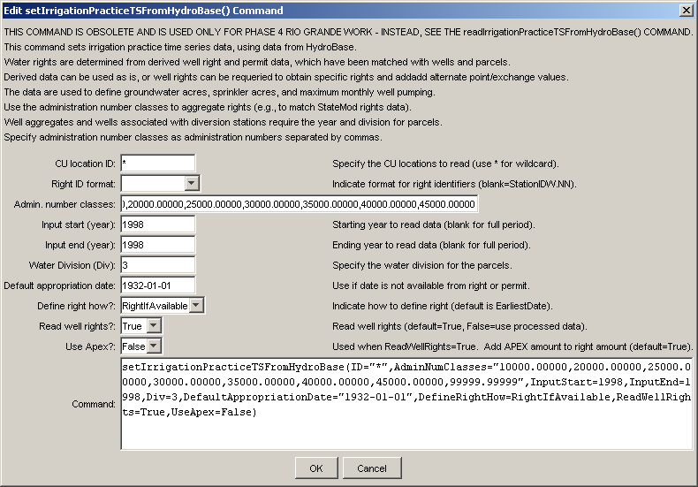
setIrrigationPracticeFromHydroBase
setIrrigationPracticeTSFromHydroBase() Command Editor
The command syntax is as follows:

setIrrigationPracticeTSFromHydroBase(param=value,…)

Command Parameters

Parameter | Description | Default
ID | A single CU location identifier to match or a pattern using wildcards (e.g., 20*). | None – must be specified.
AdminNum  Classes | A list of administration numbers, separated by spaces or commas, to define the breaks for aggregate water rights, for well aggregates. For example, if the class breaks are 10000.000, 20000.00000, and 99999.99999, the first group will contain water rights with administration numbers <= 10000.00000, the second will contain water rights with administration number > 10000.00000 and <= 20000.00000, and the third will contain water rights with administration number > 20000.00000 and <= 99999.99999. | If not specified, well aggregates will be treated as well systems, with all water rights explicitly included in output.
InputStart | The starting calendar year to use for parcel data, needed to determine relationships between diversion stations/parcels/wells and for well aggregate/systems.  A single year or blank can be specified. | All years in HydroBase will be processed, with the most recent year being used for final groundwater acres and water rights output.
InputEnd | The ending calendar year to use for parcel data, needed to determine relationships between diversion stations/parcels/wells and for well aggregate/systems.  A single year or blank can be specified. | All years in HydroBase will be processed, with the most recent year being used for final groundwater acres and water rights output.
Div | A water division to use for parcel data, needed to determine relationships between diversion stations/parcels/wells and for well aggregate/systems. | None – must be specified.
Default  Appropriation  Date | Some right/permit data do not have a date in data records. For example, very old well permits may not have a date. In these cases a default date can be assigned to be used as the appropriation date in the well water right. The appropriation date will be converted to a State of Colorado administration number in StateMod water rights. | The administration number is set to 99999.99999.
DefineRightHow | Wells (holes in the ground) are matched with water rights, well permits, and occasionally “estimated” wells necessary because a water right or permit could not be found. In some cases a right and permit will both exist for a well, each with their own dates. This parameter indicates how to define the right in these cases. A value of EarliestDate will use the earliest date determined from the right’s appropriation date and the permit’s permit date. A value of RightIfAvailable will always use the water right appropriation date, if available. | EarliestDate
ReadWellRights | This parameter is only used when DefineRightHow=RightIfAvailable, and indicates whether individual water rights should be read from HydroBase. The following values are recognized:  - True – the net amounts data are read, which may result in multiple well water rights for a well WDID. See also the UseApex parameter.  - False – then a single processed water right will be returned, which is the sum of net amount rights, using the oldest appropriation date found for the rights (APEX is not considered). | True
UseApex | Indicate whether to use alternate point/exchange values when processing rights. The following values are recognized:  - True – the APEX values corresponding to well rights are added to the net amount right values, resulting in a larger decree being considered for some rights.  - False – the APEX values are not added to net amount rights.  Because net amount rights usually either have a decreed rate or an APEX amount, using True will generally result in more water rights, where the resulting right amount is either the decree or APEX. | False

This page is intentionally blank.

