Command Reference: setIrrigationPracticeTSFromStateCU()

Set irrigation practice time series data from information in a StateCU file

StateCU Command
Version 01.07.00, 2004-04-06, Color, Acrobat Distiller

The setIrrigationPracticeFromStateCU() command sets irrigation practice data for existing CU Locations by reading information from a StateCU file. New locations are not added. Currently, this command will only set the total irrigated acreage, using data from a crop pattern time series file. The total acreage in the irrigation practice time series file is used by StateMod, which does read the irrigation practice file, but not the crop pattern file. The following dialog is used to edit the command and illustrates the syntax of the command.

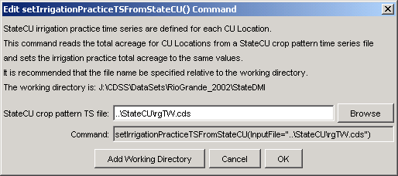
setIrrigationPracticeTSFromStateCU
setIrrigationPracticeTSFromStateCU() Command Editor

The command syntax is as follows:

setIrrigationPracticeTSFromStateCU(param=value)

Command Parameters

Parameter | Description | Default
InputFile | Path to the StateMod file to read. | None – must be specified.

