Command Reference: setIrrigationPracticeTSMaxPumpingToRights()

Set the irrigation practice max pumping time series (yearly) to well rights

StateCU Command
Version 02.14.00, 2007-07-03, Color, Acrobat Distiller

THIS COMMAND IS OBSOLETE – INSTEAD, USE THE setIrrigationPracticeTSPumpingMaxUsingWellRights() COMMAND. This older command was used for Phase 4 Río Grande work, and only works with one year of parcel data (e.g., 1998). However, an entirely new procedure has now been implemented, which can be applied to all basins. The new procedure relies on processing water rights into a StateMod water rights file and then using this file as input when processing parcels for the irrigation practice time series. Other commands have also been implemented to allow more control over acreage processing.

The setIrrigationPracticeTSMaxPumpingToRights() command sets irrigation practice maximum well pumping time series (yearly) values to the water rights that were in effect at the time of the well, based on the appropriation date corresponding to water right administration numbers. The functionality of this command is similar to the limitDiversionHistoricalTSMonthlyToRights()command; however, the maximum pumping is simply set to the water rights. For each CU location being processed that has water supply from one or more wells, the cumulative rights are determined at each point in time, creating a step-function in CFS units. Very junior water rights with administration numbers greater than or equal to 90000.00000 can be assigned an appropriate date, which is then used to compute an administration number for the check. The water rights can be supplied from a StateMod well rights file or from a list of rights in memory (e.g., as the result of the setIrrigationPracticeTSFromHydroBase() command). Water rights from a file may include the effects of set commands. For boundary purposes during the check, a zero flow condition is imposed at 1800-01-01 and carried forward until a right is found. A summary of the rights is printed to the log file.

If necessary, place set commands after the setIrrigationPracticeTSMaxPumpingToRights() command so that the set commands will not be impacted by the setIrrigationPracticeTSMaxPumpingToRights() command.

The water rights switch in the StateMod rights is handled as follows:

- If the switch is zero, the water right is ignored in processing (it is not used to limit the data).
- If the switch is 1, no adjustments are done to the appropriation date for the water right.
- If the switch is +YYYY (indicating that the right should turn on in the given year):
  - If the UseOnOffDate parameter is True, the appropriation date for the water right is set to YYYY-01-01 during the limit process.
  - If the UseOnOffDate parameter is False, the appropriation date from the administration number is used.
- If the switch is -YYYY (indicating that the right should turn off after the given year):
  - If the UseOnOffDate parameter is True, the appropriation date for the water right is set to (YYYY+1)-01-01 and the decree is set to negative during the limit process.
  - If the UseOnOffDate parameter is False, the appropriation date from the administration number is used and the decree is set to negative during the limit process.

If the administration number cannot be converted to an appropriation date, then the water right OnOff switch can be set to a year for each water right and UseOnOffDate=True should be specified.

If the sum of the water rights decrees is less than zero, it is reset to zero.

A summary of the logic is as follows:

For each CU location:

- Determine the water rights for the CU location. If no rights are available, skip the remaining steps.
- Determine the irrigation practice time series (yearly). If no time series is available, skip the remaining steps.
- Process the water rights for the CU location.
  - Convert the administration number to appropriation date. Use the same code as the Administration Number Calculator tool in StateView. The prior adjudication date associated with the administration number is ignored. See the explanation above for how the water rights switch is handled.
  - Sort the rights according to the Julian day value for the appropriation date.
  - If the CU location has a free water right (those with administration numbers greater than or equal to 90000.00000): If the CU location has a senior water right, convert the free water right appropriation date to that of the senior water right (therefore the free water right is in effect since the time of the senior right). If the CU location has no senior water right (it has only free water right[s]), use the appropriation date corresponding to the FreeWaterAppropriationDate parameter described below.
  - Add a bounding zero decree for 1800-01-01 for the early period of the step function.
  - Generate a step function of sorted dates and decrees using the information described above. These values will be in CFS. Because appropriation dates are used, the sort order may be different from that of the numerical administration number.
  - Because the decrees are in CFS, convert to ACFT, considering the number of days in each month, to determine a maximum pumping ACFT per month. Because of the conversion from CSFS to ACFT, monthly values in the step function will vary.
  - Using the monthly maximum values (January through December), determine the maximum monthly pumping for a year. The step-function will then use dates with a yearly precision because the value in the irrigation practice time series is the maximum monthly pumping in each year.
- Set the yearly maximum pumping time series to the step function, where the step function is defined by a list of dates and decrees, determined from the previous step. The full period will be set.

The following dialog is used to edit the command and illustrates the syntax of the command.

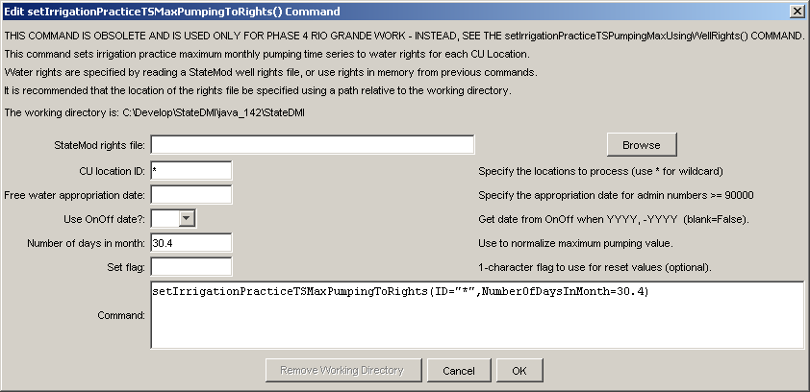
setIrrigationPracticeTSMaxPumpingToRights
setIrrigationPracticeTSMaxPumpingToRights() Command Editor

The command syntax is as follows:

setIrrigationPracticeTSMaxPumpingToRights(param=value,…)

Command Parameters

Parameter | Description | Default
InputFile | The name of the StateMod well rights file, surrounded by double quotes. The rights in the file are read and are used to set the CU location maximum pumping time series. The rights are assumed to be sorted by structure.  If in-memory rights resulting from the readIrrigationPracticeTSFromHydroBase() command are used (InputFile is blank), these rights may not exactly match those read from a StateMod well rights file. The rights file may include the effects of set commands. | Use StateMod well rights in memory, from previous commands.
ID | A single CU location identifier to match or a pattern using wildcards (e.g., 20*). | None – must be specified.
FreeWater  Appropriation  Date | A date to be used for the free water rights found in the rights file. Free water rights are typically inserted to represent very junior rights. Rights having an administration number greater than or equal to 90000.00000 are assumed to be free water rights and will use the specified free water appropriation date when constraining the time series. | The date corresponding to an administration number of 0, which is Dec 31, 1849.
UseOnOffDate | If False, the appropriation date is always computed from the administration number. If True and the value of the OnOff switch for a right is YYYY or –YYYY, assign the appropriation date using the switch value (see notes earlier in the command description). | False
NumberOfDays  InMonth | The number of days in a month. This is used when a constant value is needed. | Use the number of days in the month corresponding to the water right/permit date.
SetFlag | If specified as a single character, data flags will be enabled for the time series and each set value will be tagged with the specified character. The flag can then be used later to label graphs, etc. The flag will be appended to existing flags if necessary. This parameter is passed to the same features as used in the limit*ToRights() commands. | No flag is assigned.

