Command Reference: SetIrrigationPracticeTSSprinklerAcreageFrom List()

Set irrigation practice time series sprinkler acreage time series values using a list file

StateCU Command
Version 3.09.01, 2010-02-01

The SetIrrigationPracticeTSSprinklerAcreageFromList() command sets irrigation practice time series sprinkler acreage data for a CU Location, using data from a list file, and adjusts other acreage terms accordingly to maintain the total acreage. This command is typically applied after all other data read and filling occurs, in order to utilize sprinkler acreage data that has been obtained for historical years. For example, the command is used in the Río Grande because user supplied sprinkler data are available, but may not be applied in the South Platte, where more years of irrigated lands data are in HydroBase. The list file typically contains sprinkler acreage by model location for the full period and may have been interpolated between observations and repeated on the ends of the period.

Prerequisites:

- This command should be executed after the irrigation practice time series are read from HydroBase (see ReadIrrigationPracticeTSFromHydroBase()).
- Total acreage has been set to the crop pattern time series total (see SetIrrigationPracticeTSTotalAcreageToCropPatternTSTotalAcreage()). The total acres are needed for checks.
- The groundwater acreage should also have been filled using well rights before the first year of observations using FillIrrigationPracticeTSAcreageUsingWellRights().
- The surface water acreage should have been filled during the early period using FillIrrigationPracticeTSInterpolate().
- The end of the period should have acreage filled using FillIrrigationPracticeTSRepeat().

The following dialog is used to edit the command and illustrates the syntax of the command.

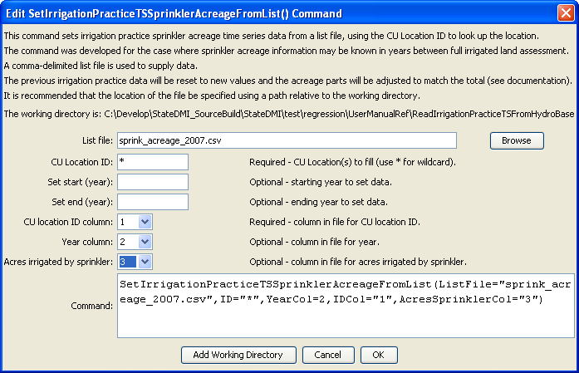
SettIrrigationPracticeTSSprinklerAcreageFromList
SetIrrigationPracticeTSSprinklerAcreageFromList() Command Editor

The sprinkler list file is processed one record at a time. The following check is done after setting the sprinkler acreage for a location and year:

- Set the groundwater sprinkler acreage (GWsprinkler) to the minimum of the list file sprinkler acreage (ListFile) and the previous groundwater sprinkler value (GWprev).
- Set the surface water sprinkler acreage (SWsprinkler to min((ListFile – GWsprinkler), SWprev). Then ensures that a negative number does not result.
- Set the groundwater flood acreage (GWflood) to the previous groundwater total minus the groundwater sprinkler (GWsprinkler) acreage. This may result in a zero value based on previous adjustments.
- Set the surface water flood acreage (SWflood) to the previous surface water total minus surface water sprinkler acres. This may result in a zero value based on previous adjustments.

The command syntax is as follows:

SetIrrigationPracticeTSSprinklerAcreageFromList(Parameter=Value,…)

Command Parameters

Parameter | Description | Default
ListFile | Name of comma-delimited file containing sprinkler acreage for locations over time. | None – must be specified.
ID | A single CU Location identifier to match or a pattern using wildcards (e.g., 20*). | None – must be specified.
SetStart | The first year to set data. | If not specified, set the full period, using all available data from the list file.
SetEnd | The last year to set data. | If not specified, set the full period, using all available data from the list file.
IDCol | The column (1+) in the list file containing the location ID. | None – must be specified.
YearCol | The column (1+) in the list file containing the year. | None – must be specified.
AcresSprinklerCol | The column (1+) in the list file containing the sprinkler acres for the location and year. | None – must be specified.

This page is intentionally blank.

