Command Reference: setIrrigationPracticeTSSprinklerAreaFromList()

Set sprinkler area data in the irrigation practice time series (yearly), using a parcel list and data in HydroBase

StateCU Command
Version 02.14.00, 2007-07-03, Color, Acrobat Distiller

THIS COMMAND IS OBSOLETE – INSTEAD, USE THE setIrrigationPracticeTSSprinklerAcreageFromList() COMMAND. This older command was used for Phase 4 Río Grande work. However, an entirely new procedure has now been implemented, which can be applied to all basins. The new procedure relies on processing water rights into a StateMod water rights file and then using this file as input when processing parcels for the irrigation practice time series. Other commands have also been implemented to allow more control over acreage processing.

The setIrrigationPracticeTSSprinklerAreaFromList() command reads a list of parcels from a list file and then uses the parcels from HydroBase to define sprinkler acreage. This command was implemented to process data from the Río Grande basin but could also be used in other data sets. The normal irrigated lands assessment was performed using parcel data for 1998. Additional maps were available back in time, which were used to indicate the 1998 parcels that were irrigated by sprinklers in other years (e.g., indicated by circular parcels in the historical maps). Consequently, the parcel data from 1998 are used, but the resulting subset of parcels is assigned to a year other than 1998 in the irrigation practice time series file.

The logic used to process the data is similar to that of the readIrrigationPracticeTSFromHydroBase() command, with the following differences:

- Only sprinkler acres are processed. Water rights and groundwater acres are not set in the results. A single historical year of sprinkler acreage is assigned per list file.
- The parcel data from HydroBase is checked and only the parcel identifiers that match the list file are processed. The parcels that are in the list have their irrigation type set to SPRINKLER during processing so that all of the parcels are accounted for in the sprinkler acreage. Extra parcels in the list file that are not in HydroBase for the requested year are ignored.

The following dialog is used to edit the command and illustrates the syntax of the command.

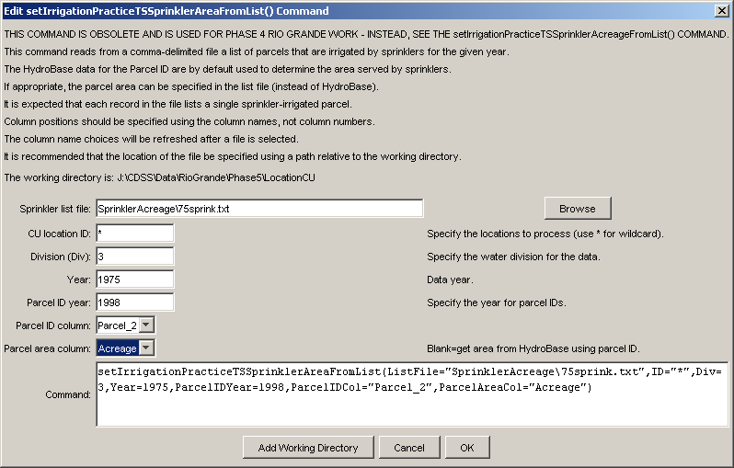
setIrrigationPracticeTSSprinklerAreaFromList
setIrrigationPracticeTSSprinklerAreaFromList() Command Editor

The command syntax is as follows:

setIrrigationPracticeTSSprinklerAreaFromList(param=value,…)

Command Parameters

Parameter | Description | Default
ListFile | Path to the delimited list file to read. | None – must be specified.
ID | A single CU location identifier to match or a pattern using wildcards (e.g., 20*). | None – must be specified.
Div | Water division for the data. This is important because parcel data in HydroBase are uniquely identified using the division. | None – must be specified.
Year | Year for the sprinkler data to be assigned (the results). | None – must be specified.
ParcelIDYear | Year for the parcel identifiers from HydroBase (the input). This is important because parcel data in HydroBase are uniquely identified using the year and may vary by year. | None – must be specified.
ParcelIDCol | The column name in the list file containing the parcel identifier. | None – must be specified.
ParcelAreaCol | The column name in the list file containing the parcel area, if this information is to be used instead of the areas in HydroBase. This feature was used during development. | None – must be specified.

An excerpt from an example list file is shown below:

# 1975 Parcels that are irrigated by sprinklers
# One parcel identifier per line is specified. The parcel identifiers
# agree with those for 1998 in HydroBase.
"Year","Parcel"
1975,10107
1975,10108
1975,10123
…
1975,10198
1975,10202
…

Lines in the file starting with the # character are treated as comments. If the first non-comment line’s values are surrounded by double quotes, the line is assumed to indicate column headings. Column headers are a requirement for this command because they are used to indicate the column for input. Note that extra columns can be included in the file and will be ignored. In the above example, only the “Parcel” column is used during processing.

This page is intentionally blank.

