Command Reference: SetOutputPeriod()
Set the Output Period for Time Series

General Command
Version 3.08.02, 2010-01-07

The SetOutputPeriod() command sets the output period for time series. Specifying the output period is necessary when creating model files or filling an extended period (time series will not automatically be extended by fill commands). The following dialog is used to edit this command and illustrates the syntax of the command. Note that the output period should always use calendar month and year, even if other than calendar year are used for output (see SetOutputYearType()).

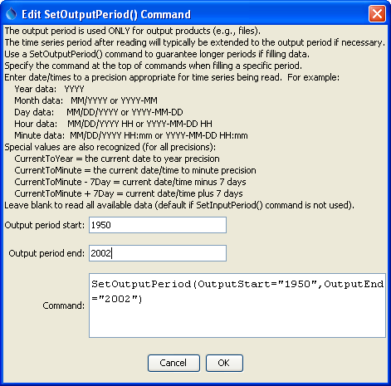
SetOutputPeriod
SetOutputPeriod() Command Editor

The command syntax is as follows:

SetOutputPeriod(Parameter=Value,…)

Command Parameters

Parameter | Description | Default
OutputStart | The output period start, in a standard date/time format. The precision of this value should match that of data because it is used to iterate through the data. For example, if monthly data are being processed, specify the OutputStart using year and month. | None – must be specified.
OutputEnd | The output period end, in a standard date/time format. The precision of this value should match that of data because it is used to iterate through the data. For example, if monthly data are being processed, specify the OutputStart using year and month. | None – must be specified.

