Command Reference: SetOutputYearType()
Set the output year type for time series and other data

General Command
Version 3.08.02, 2010-01-07

The SetOutputYearType() command sets the output year type for time series and other time-dependent data (e.g., the order of monthly efficiencies in the StateMod diversion stations file depends on the year type). The output period used with SetOutputPeriod() should always use calendar month and year, even if other than calendar year are used for the output year type. The following dialog is used to edit this command and illustrates the syntax of the command.

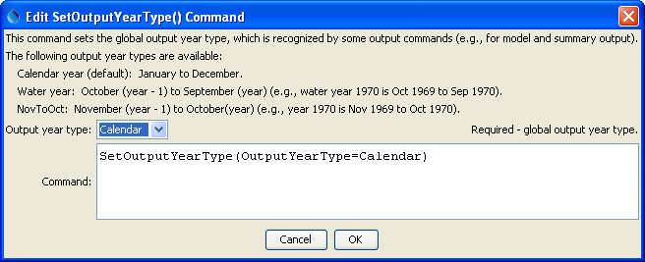
SetOutputYearType
SetOutputYearType() Command

The command syntax is as follows:

SetOutputYearType(Parameter=Value,…)

Command Parameters

Parameter | Description | Default
OutputYearType | The output year type, one of:  Calendar – each year is Jan – Dec.  NovToOct – each year is Nov of the previous year to Oct of the current year  Water – each water year is Oct of the previous year to Sep of the current year. | None – must be specified.

