Command Reference: SetPlanStation()

Set plan station data

StateMod Command
Version 3.12.00, 2010-12-15

The SetPlanStation() command sets data in existing plan stations or adds a new plan station. The following dialog is used to edit the command and illustrates the syntax of the command (the data in this example are contrived).

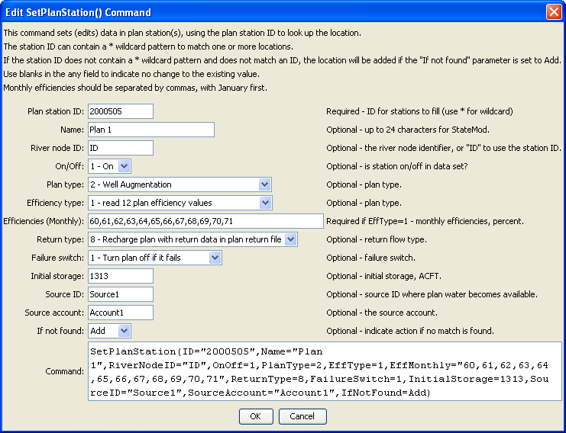
SetPlanStation
SetPlanStation() Command Editor

The command syntax is as follows:

SetPlanStation(Parameter=Value,…)

Command Parameters

Parameter | Description | Default
ID | A single plan station identifier to match or a pattern using wildcards (e.g., 20*). | None – must be specified.
Name | The name to be assigned for all matching plan stations. | If not specified, the original value will remain.
RiverNodeID | The river node identifier to be assigned for all matching plan stations. Specify ID to assign to the plan station identifier. | If not specified, the original value will remain.
OnOff | The on/off switch value to be assigned for all matching plan stations, either 1 for on or 0 for off. | If not specified, the original value will remain.
PlanType | The plan station type to be assigned for all matching plan stations (see StateMod documentation). | If not specified, the original value will remain.
EffType | The efficiency type to assign for all matching plan stations (see StateMod documentation). | If not specified, the original value will remain.
EffMonthly | The monthly efficiencies (percent, 0 – 100) to assign for all matching plan stations, specified as 12 comma-separated values, January to December. | If not specified, the original values will remain.
ReturnType | The return flow type to be assigned for all matching plan stations (see StateMod documentation). | If not specified, the original value will remain.
FailureSwitch | The failure switch to be assigned for all matching plan stations (see StateMod documentation). | If not specified, the original value will remain.
InitialStorage | The initial plan storage (ACFT) to be assigned for all matching plan stations. | If not specified, the original value will remain.
SourceID | The source identifier to be assigned for all matching plan stations. | If not specified, the original value will remain.
UserName | The source account to be assigned for all matching plan stations. | If not specified, the original value will remain.
IfNotFound | Used for error handling, one of the following:  - Add – add the diversion station if the ID is not matched and is not a wildcard  - Fail – generate a failure message if the ID is not matched  - Ignore – ignore (don’t add and don’t generate a message) if the ID is not matched  - Warn – generate a warning message if the ID is not matched | Warn

