Command Reference: SetReservoirAggregate ()

Set reservoir aggregate parts

StateMod Command
Version 3.09.01, 2010-02-01

The SetReservoirAggregate() command sets reservoir aggregate part identifier data for a reservoir. Aggregate reservoirs are defined as a combination of other reservoirs and may be used, for example, to aggregate stock ponds or other small reservoirs. This command should be specified before commands that need aggregate information during processing (e.g., those that read data from HydroBase). The following dialog is used to edit the command and illustrates the syntax of the command.

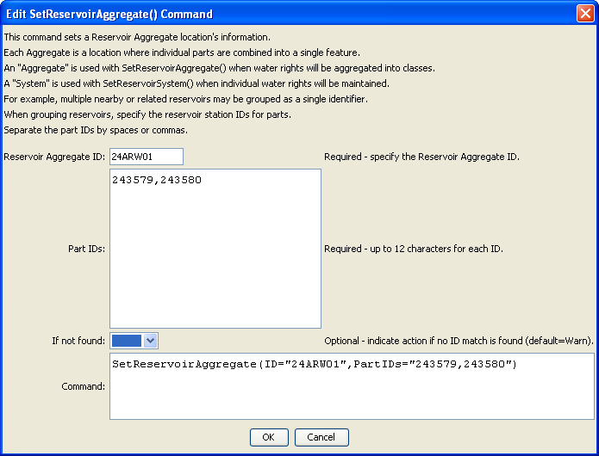
SetReservoirAggregate
SetReservoirAggregate() Command Editor

The command syntax is as follows:

SetReservoirAggregate(Parameter=Value,…)

Command Parameters

Parameter | Description | Default
ID | The reservoir identifier to associate with the aggregate part identifiers. | None – must be specified.
PartIDs | The list of part identifiers to comprise the aggregate. | None – must be specified.
IfNotFound | Used for error handling, one of the following:  - Fail – generate a failure message if the ID is not matched  - Ignore – ignore (don’t add and don’t generate a message) if the ID is not matched  - Warn – generate a warning message if the ID is not matched | Warn

