Command Reference: SetReservoirRight()

Set reservoir right data

StateMod Command
Version 3.09.01, 2010-02-01

The SetReservoirRight() command sets data in existing reservoir rights or adds a new reservoir right. If a new right is added, it is added in alphabetical order according to the right identifier. The following dialog is used to edit the command and illustrates the syntax of the command.

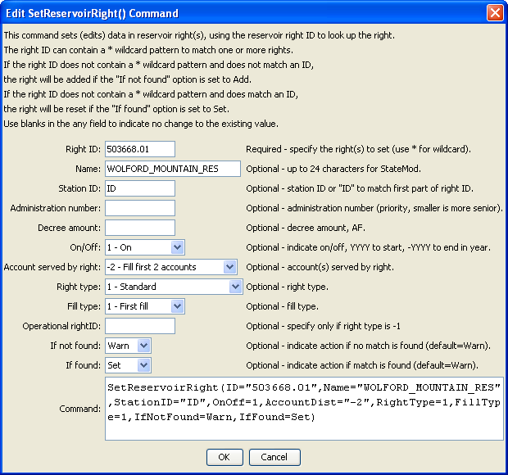
SetReservoirRight
SetReservoirRight() Command Editor

The command syntax is as follows:

SetReservoirRight(Parameter=Value,…)

Command Parameters

Parameter | Description | Default
ID | A single reservoir right identifier to match or a pattern using wildcards (e.g., 20*). | None – must be specified.
Name | The name to be assigned for all matching reservoir rights. | If not specified, the original value will remain.
StationID | The reservoir station identifier to be assigned for all matching reservoir rights. | If not specified, the original value will remain.
Administration  Number | The administration number to be assigned for all matching reservoir rights. | If not specified, the original value will remain.
Decree | The water right decree to be assigned for all matching reservoir rights. | If not specified, the original value will remain.
OnOff | The on/off switch value to be assigned for all matching reservoir rights, either 1 for on or 0 for off, a positive 4-digit year to turn the right on starting in the year, or a negative 4-digit year to turn the right off starting in the year. | If not specified, the original value will remain.
AccountDist | The account distribution option to be assigned for all matching reservoir rights (see StateMod documentation). | If not specified, the original value will remain.
RightType | The reservoir right type to be assigned for all matching reservoir rights (see StateMod documentation). | If not specified, the original value will remain.
FillType | The reservoir right fill type to be assigned for all matching reservoir rights (see StateMod documentation). | If not specified, the original value will remain.
OpRightID | The out-of-priority associated operational right (see StateMod documentation). | If not specified, the original value will remain.
IfNotFound | Used for error handling, one of the following:  - Add – add the reservoir right if the ID is not matched and is not a wildcard  - Fail – generate a failure message if the ID is not matched  - Ignore – ignore (don’t add and don’t generate a message) if the ID is not matched  - Warn – generate a warning message if the ID is not matched | Warn
IfFound | Used for error handling, one of the following:  - Set – set the reservoir right if the ID is matched  - Fail – generate a failure message if the ID is matched  - Ignore – ignore (don’t add and don’t generate a message) if the ID is matched  - Warn – generate a warning message if the ID is matched | Warn

