Command Reference: SetRiverNetworkNode()

Set river network node data

StateMod Command
Version 3.09.01, 2010-02-01

The SetRiverNetworkNode() command sets data in existing river network nodes or adds a new river network node. The following dialog is used to edit the command and illustrates the syntax of the command.

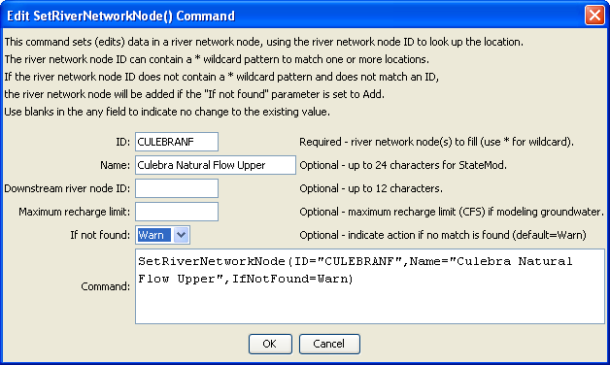
SetRiverNetworkNode
SetRiverNetworkNode() Command Editor

The command syntax is as follows:

SetRiverNetworkNode(Parameter=Value,…)

Command Parameters

Parameter | Description | Default
ID | A single river network node identifier to match or a pattern using wildcards (e.g., 20*). | None – must be specified.
Name | The name to be assigned for all matching river network nodes. | If not specified, the original value will remain.
DownstreamRiverNodeID | The downstream river node identifier to be assigned for all matching river network nodes. | If not specified, the original value will remain.
Comment | The comment to be assigned for all matching river network nodes. | If not specified, the original value will remain.
MaxRechargeLimit | The maximum recharge limit, CFS, for groundwater modeling, assigned for all matching river network nodes. | If not specified, the original value will remain.
IfNotFound | Used for error handling, one of the following:  - Add – add the river network node if the ID is not matched and is not a wildcard (note that nodes that are upstream and downstream of the addition are NOT automatically changed)  - Fail – generate a failure message if the ID is not matched  - Ignore – ignore (don’t add and don’t generate a message) if the ID is not matched  - Warn – generate a warning message if the ID is not matched | Warn

