Command Reference: SetStreamEstimateCoefficients()

Set stream estimate coefficients data

StateMod Command
Version 3.09.01, 2010-02-01

The SetStreamEstimateCoefficients() command sets data in existing stream estimate coefficients – the previous values will be overwritten. If base or gain data are specified, the original values will be replaced (not appended). The following dialog is used to edit the command and illustrates the syntax of the command.

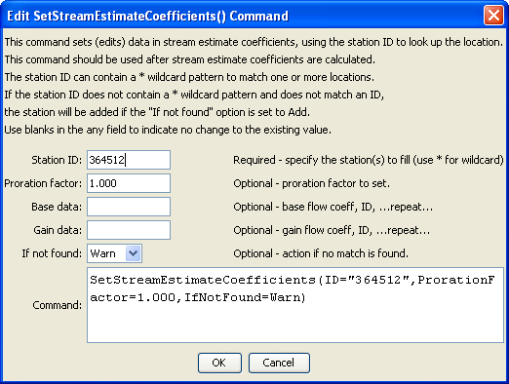
SetStreamEstimateCoefficients
SetStreamEstimateCoefficients() Command Editor

The command syntax is as follows:

SetStreamEstimateCoefficients(Parameter=Value,…)

Command Parameters

Parameter | Description | Default
ID | A single stream estimate station identifier to match or a pattern using wildcards (e.g., 20*). | None – must be specified.
Proration  Factor | The proration factor for all matching stream estimate stations. | If not specified, the original value will remain.
BaseData | The base flow coefficient and station ID pairs to be assigned for all matching stream estimate stations. Repeat for as many pairs as necessary, separated by commas. | If not specified, the original value will remain.
GainData | The gain flow coefficient and station ID pairs to be assigned for all matching stream estimate stations. Repeat for as many pairs as necessary, separated by commas. | If not specified, the original value will remain.
IfNotFound | Used for error handling, one of the following:  - Add – add the stream estimate coefficients if the ID is not matched and is not a wildcard  - Fail – generate a failure message if the ID is not matched  - Ignore – ignore (don’t add and don’t generate a message) if the ID is not matched  - Warn – generate a warning message if the ID is not matched | Warn

The following command file illustrates how a StateMod stream estimate coefficients file can be created:

StartLog(LogFile="rib.commands.StateDMI.log")
# rib.commands.StateDMI
#
# Creates the Stream Estimate Station Coefficient Data file
#
# Step 1 - read river nodes from the network file and create file framework
#
ReadStreamEstimateStationsFromNetwork(InputFile="..\Network\cm2005.net")
#
# Step 2 - set preferred gages for "neighboring" gage approach
# this baseflow nodes are generally on smaller non-gaged tribs and have
# different flow characteristics than next downstream gages
#
SetStreamEstimateCoefficientsPFGage(ID="360645",GageID="09055300")
...similar commands omitted…
#
# Step 3 - calculate stream coefficients
CalculateStreamEstimateCoefficients()
#
# Step 4 - set proration factors directly
#
SetStreamEstimateCoefficients(ID="364512",ProrationFactor=1.000,IfNotFound=Warn)
…similar commands omitted…
#
# Step 5 - create streamflow estimate coefficient file
#
WriteStreamEstimateCoefficientsToStateMod(OutputFile="..\StateMOD\cm2005.rib")
#
# Check the results
CheckStreamEstimateCoefficients(ID="*")
WriteCheckFile(OutputFile="rib.commands.StateDMI.check.html")

