Command Reference: SetStreamEstimateCoefficientsPFGage()

Set stream estimate coefficients to use a specific gage for proration factor calculations

StateMod Command
Version 3.09.01, 2010-02-01

The SetStreamEstimateCoefficientsPFGage() command indicates that the proration factor for a specified station/node should be calculated using only the area*precipitation value for the specified stream gage, rather than the next downstream node. The station/node is then treated as if it were a stream gage node for other natural flow calculations (as carried out by the CalculateStreamEstimateCoefficients() command). These commands should be specified before the CalculateStreamEstimateCoefficients() command.

The following dialog is used to edit the command and illustrates the syntax of the command.

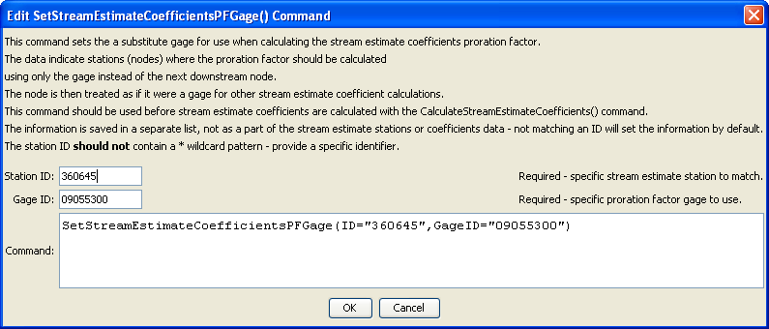
SetStreamEstimateCoefficientsPFGage
SetStreamEstimateCoefficientsPFGage() Command Editor

The command syntax is as follows:

SetStreamEstimateCoefficientsPFGage(Parameter=Value,…)

Command Parameters

Parameter | Description | Default
ID | A single stream estimate station identifier to match. | None – must be specified.
GageID | A stream gage station identifier to use, instead of the downstream gage. | None – must be specified.

The following command file illustrates how a StateMod stream estimate coefficients file can be created:

StartLog(LogFile="rib.commands.StateDMI.log")
# rib.commands.StateDMI
#
# Creates the Stream Estimate Station Coefficient Data file
#
# Step 1 - read river nodes from the network file and create file framework
#
ReadStreamEstimateStationsFromNetwork(InputFile="..\Network\cm2005.net")
#
# Step 2 - set preferred gages for "neighboring" gage approach
# this baseflow nodes are generally on smaller non-gaged tribs and have
# different flow characteristics than next downstream gages
#
SetStreamEstimateCoefficientsPFGage(ID="360645",GageID="09055300")
SetStreamEstimateCoefficientsPFGage(ID="360801",GageID="09055300")
SetStreamEstimateCoefficientsPFGage(ID="362002",GageID="09054000")
SetStreamEstimateCoefficientsPFGage(ID="360829",GageID="09047500")
..similar commands omitted…
#
# Step 3 - calculate stream coefficients
CalculateStreamEstimateCoefficients()
#
# Step 4 - set proration factors directly
#
SetStreamEstimateCoefficients(ID="364512",ProrationFactor=1.000,IfNotFound=Warn)
SetStreamEstimateCoefficients(ID="374641",ProrationFactor=0.200,IfNotFound=Warn)
SetStreamEstimateCoefficients(ID="374648",ProrationFactor=0.350,IfNotFound=Warn)
SetStreamEstimateCoefficients(ID="380880",ProrationFactor=1.000,IfNotFound=Warn)
SetStreamEstimateCoefficients(ID="381594",ProrationFactor=0.800,IfNotFound=Warn)
SetStreamEstimateCoefficients(ID="384617",ProrationFactor=0.700,IfNotFound=Warn)
SetStreamEstimateCoefficients(ID="510639",ProrationFactor=1.000,IfNotFound=Warn)
SetStreamEstimateCoefficients(ID="514603",ProrationFactor=0.800,IfNotFound=Warn)
SetStreamEstimateCoefficients(ID="514620",ProrationFactor=1.000,IfNotFound=Warn)
SetStreamEstimateCoefficients(ID="510728",ProrationFactor=1.000,IfNotFound=Warn)
SetStreamEstimateCoefficients(ID="530555",ProrationFactor=0.180,IfNotFound=Warn)
SetStreamEstimateCoefficients(ID="530678",ProrationFactor=0.230,IfNotFound=Warn)
SetStreamEstimateCoefficients(ID="531082",ProrationFactor=1.000,IfNotFound=Warn)
SetStreamEstimateCoefficients(ID="954683",ProrationFactor=0.400,IfNotFound=Warn)
#
# Step 5 - create streamflow estimate coefficient file
#
WriteStreamEstimateCoefficientsToStateMod(OutputFile="..\StateMOD\cm2005.rib")
#
# Check the results
CheckStreamEstimateCoefficients(ID="*")
WriteCheckFile(OutputFile="rib.commands.StateDMI.check.html")

