Command Reference: SetStreamEstimateStation()

Set stream estimate station data

StateMod Command
Version 3.09.01, 2010-02-01

The SetStreamEstimateStation() command sets data in existing stream estimate stations or adds a new stream estimate station. The following dialog is used to edit the command and illustrates the syntax of the command.

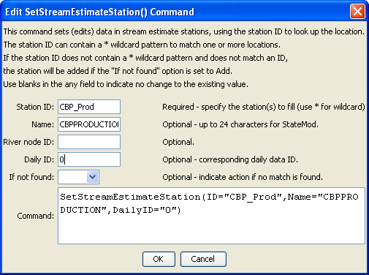
SetStreamEstimateStation
SetStreamEstimateStation() Command Editor

The command syntax is as follows:

SetStreamEstimateStation(Parameter=Value,…)

Command Parameters

Parameter | Description | Default
ID | A single stream estimate station identifier to match or a pattern using wildcards (e.g., 20*). | None – must be specified.
Name | The name to be assigned for all matching stream estimate stations. | If not specified, the original value will remain.
RiverNodeID | The river node identifier to be assigned for all matching stream estimate stations. | If not specified, the original value will remain.
DailyID | The daily identifier to be assigned for all matching stream estimate stations. | If not specified, the original value will remain.
IfNotFound | Used for error handling, one of the following:  - Add – add the stream estimate station if the ID is not matched and is not a wildcard  - Fail – generate a failure message if the ID is not matched  - Ignore – ignore (don’t add and don’t generate a message) if the ID is not matched  - Warn – generate a warning message if the ID is not matched | Warn

