Command Reference: SetStreamGageStation()

Set stream gage station data

StateMod Command
Version 3.09.01, 2010-02-01

The SetStreamGageStation () command sets data in existing stream gage stations or adds a new stream gage station. The following dialog is used to edit the command and illustrates the syntax of the command.

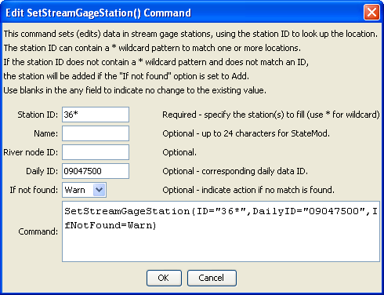
SetStreamGageStation
SetStreamGageStation() Command Editor

The command syntax is as follows:

SetStreamGageStation(Parameter=Value,…)

Command Parameters

Parameter | Description | Default
ID | A single stream gage station identifier to match or a pattern using wildcards (e.g., 20*). | None – must be specified.
Name | The name to be assigned for all matching stream gage stations. | If not specified, the original value will remain.
RiverNodeID | The river node identifier to be assigned for all matching stream gage stations. | If not specified, the original value will remain.
DailyID | The daily identifier to be assigned for all matching stream gage stations. | If not specified, the original value will remain.
IfNotFound | Used for error handling, one of the following:  - Add – add the stream gage station if the ID is not matched and is not a wildcard  - Fail – generate a failure message if the ID is not matched  - Ignore – ignore (don’t add and don’t generate a message) if the ID is not matched  - Warn – generate a warning message if the ID is not matched | Warn

The following example command file illustrates the commands used to read stream gage stations from the network and create a StateMod file:

StartLog(LogFile="ris.commands.StateDMI.log")
# ris.commands.StateDMI
#
# StateDMI command file to create streamflow station file for the Colorado River
#
# Step 1 - read streamgages and baseflows ids from the network file
#
ReadStreamGageStationsFromNetwork(InputFile="..\Network\cm2005.net",
IncludeStreamEstimateStations="True")
#
# Step 2 - read baseflow nodes names from HydroBase,
# fill in missing names from the network file
#
FillStreamGageStationsFromHydroBase(ID="*",NameFormat=StationName,CheckStructures=True)
FillStreamGageStationsFromNetwork(ID="*",NameFormat="StationName")
#
# Step 3 - set streamgage station to use to disaggregate monthly baseflows to daily
#
# add set daily pattern gages for WD 36
SetStreamGageStation(ID="36*",DailyID="09047500",IfNotFound=Warn)
…many similar commands omitted…
#
# Step 4 - create streamflow station file
#
WriteStreamGageStationsToStateMod(OutputFile="..\StateMod\cm2005.ris")
#
# Check the results
CheckStreamGageStations(ID="*")
WriteCheckFile(OutputFile="ris.commands.StateDMI.check.html")

