Command Reference: SetWarningLevel()
Set Level for Warning Messages

General Command
Version 3.08.02, 2010-01-07

The SetWarningLevel() command is used to set warning levels for the screen and log file. The following dialog is used to edit this command and illustrates the command syntax. The default is warning level 1 to the screen and 2 to the log file.

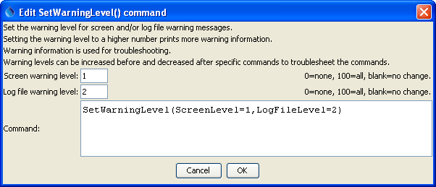
SetWarningLevel
SetWarningLevel() Command Editor

Warning messages are useful during troubleshooting. A general guideline is that a warning level of 1 prints important messages that a user should see, 2 prints warnings that by default are printed to the log file but are not displayed in the user interface, and 100 prints very low-level messages about input/output. Intermediate values will result in more or less output.

This command is useful for troubleshooting and can be specified multiple times to increase warning information for a specific command, if necessary.

This page is intentionally blank.

