Command Reference: SetWellDemandTSMonthlyConstant()

Set well demand time series (monthly) data to a constant value

StateMod Command
Version 3.09.01, 2010-02-01

The SetWellDemandTSMonthlyConstant() command sets well demand time series (monthly) data to a constant value. The output period can be set or will default to that defined by the most recent SetOutputPeriod() command. If a matching time series is not found, it can be added to the list of time series (at the end). The values that are set are treated the same as observations from HydroBase. To ensure that set values remain, use the SetWellDemandTSMonthlyConstant() command after other commands that may modify the time series.

The following dialog is used to edit the command and illustrates the syntax of the command.

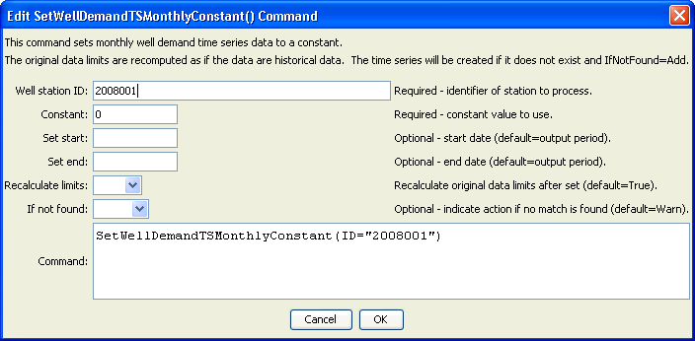
SetWellDemandTSMonthlyConstant
SetWellDemandTSMonthlyConstant() Command Editor

The command syntax is as follows:

SetWellDemandTSMonthlyConstant(Parameter=Value,…)

Command Parameters

Parameter | Description | Default
ID | A single well station identifier to match or a pattern using wildcards (e.g., 20*). | None – must be specified.
Constant | A constant well demand value. | None – must be specified.
SetStart | The start of the period for the set, in a standard date/time format for monthly data (e.g., YYYY-MM or MM/YYYY). | The output period start.
SetEnd | The end of the period for the set, in a standard date/time format for monthly data (e.g., YYYY-MM or MM/YYYY). | The output period end.
RecalcLimits | If True, then the constant values will be treated as observations and the historical averages will be recalculated with the values. False will result in the time series being set but the previous averages remaining. The averages are used with fill commands. | True
IfNotFound | Used for error handling, one of the following:  - Add – add the time series if the ID is not matched and is not a wildcard  - Fail – generate a failure message if the ID is not matched  - Ignore – ignore (don’t add and don’t generate a message) if the ID is not matched  - Warn – generate a warning message if the ID is not matched | Warn

