Command Reference: SetWellHistoricalPumpingTSMonthlyConstant()

Set well historical pumping time series (monthly) data to a constant value

StateCU and StateMod Command
Version 3.09.00, 2010-01-26

The SetWellHistoricalPumpingTSMonthlyConstant() command sets well historical pumping time series (monthly) data to a constant value. The output period can be set or will default to that defined by the most recent SetOutputPeriod() command. If a matching time series is not found, it can be added to the list of time series (at the end).

The following dialog is used to edit the command and illustrates the syntax of the command.

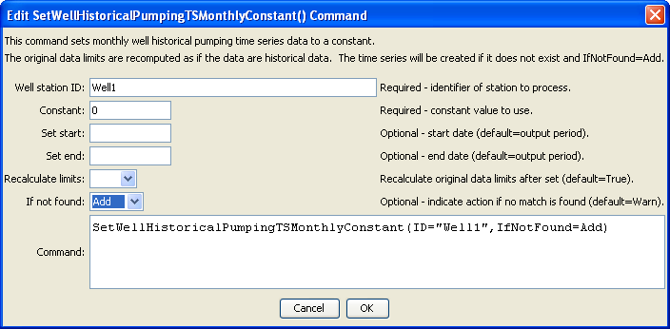
SetWellHistoricalPumpingTSMonthlyConstant
SetWellHistoricalPumpingTSMonthlyConstant() Command Editor

The command syntax is as follows:

SetWellHistoricalPumpingTSMonthlyConstant(Parameter=Value,…)

Command Parameters

Parameter | Description | Default
ID | A single well station identifier to match or a pattern using wildcards (e.g., 20*). | None – must be specified.
Constant | A constant historical value to set. | None – must be specified.
SetStart | The start of the period for the set, in a standard date/time format for monthly data (e.g., YYYY-MM or MM/YYYY). | The output period start.
SetEnd | The end of the period for the set, in a standard date/time format for monthly data (e.g., YYYY-MM or MM/YYYY). | The output period end.
RecalcLimits | If True, then the time series limits will be recalculated as if the provided values are observations. If False, the limits from before the set will remain. | True
IfNotFound | Used for error handling, one of the following:  - Add – add the time series if the ID is not matched and is not a wildcard  - Fail – generate a failure message if the ID is not matched  - Ignore – ignore (don’t add and don’t generate a message) if the ID is not matched  - Warn – generate a warning message if the ID is not matched | Warn

