Command Reference: SetWellStationAreaToCropPatternTS ()

Set the well station area to the crop pattern time series maximum

StateMod Command
Version 3.09.01, 2010-02-01

The SetWellStationAreaToCropPatternTS() command sets the well station area for each well station to the maximum crop pattern time series total area. The crop pattern time series must have been read or assigned with previous commands. If there is no crop pattern time series, the area will not be set.

The following dialog is used to edit the command and illustrates the syntax of the command.

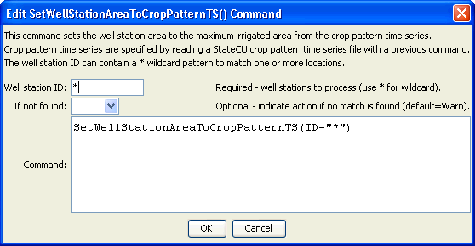
SetWellStationAreaToCropPatternTS
SetWellStationAreaToCropPatternTS() Command Editor
The command syntax is as follows:

SetWellStationAreaToCropPatternTS(Parameter=Value,…)

Command Parameters

Parameter | Description | Default
ID | A single well station identifier to match or a pattern using wildcards (e.g., 20*). | None – must be specified.
IfNotFound | Used for error handling, one of the following:  - Fail – generate a failure message if the ID is not matched  - Ignore – ignore (don’t add and don’t generate a message) if the ID is not matched  - Warn – generate a warning message if the ID is not matched | Warn

The following command file excerpt illustrates how the crop pattern time series can be used to set the irrigated area for the well stations:

ReadCropPatternTSFromStateCU(InputFile="..\Crops\Sp2008L.cds")
SetWellStationAreaToCropPatternTS(ID="*")

