Command Reference: SetWellStationCapacitiesFromTS()

Set well station capacity data as maximum historical pumping

StateCU and StateMod Command
Version 3.09.01, 2010-01-27

The SetWellStationCapacitiesFromTS() command sets well station capacities to the maximum historical pumping time series (monthly) value. The historical time series must have been previously read or calculated with other commands. Monthly ACFT values are converted to CFS units by applying the conversion:

CFS = X ACFT/(1.9835*DaysInMonth)

The following dialog is used to edit the command and illustrates the syntax of the command.

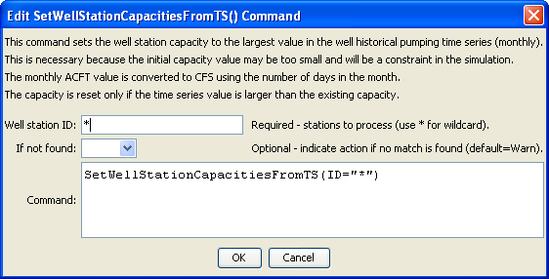
SetWellStationCapacitiesFromTS
SetWellStationCapacitiesFromTS() Command Editor

The command syntax is as follows:

SetWellStationCapacitiesFromTS(Parameter=Value,…)

Command Parameters

Parameter | Description | Default
ID | A single well station identifier to match or a pattern using wildcards (e.g., 20*). | None – must be specified.
IfNotFound | Used for error handling, one of the following:  - Fail – generate a failure message if the ID is not matched  - Ignore – ignore (do not generate a message) if the ID is not matched  - Warn – generate a warning message if the ID is not matched | Warn

