Command Reference: SetWellStationCapacityToWellRights ()

Set the well station capacity to well rights

StateMod Command
Version 3.09.01, 2010-02-01

The SetWellStationCapacityToWellRights() command sets the well station capacity for each well station to the sum of the well rights corresponding to the station. The well rights must have been read or assigned with previous commands. If there are no well rights in the file, the capacity is set to zero.

The following dialog is used to edit the command and illustrates the syntax of the command.

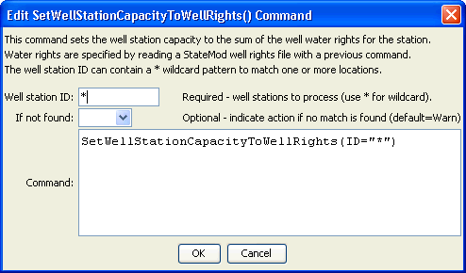
SetWellStationCapacityToWellRights
SetWellStationCapacityToWellRights() Command Editor
The command syntax is as follows:

SetWellStationCapacityToWellRights(Parameter=Value,…)

Command Parameters

Parameter | Description | Default
ID | A single well station identifier to match or a pattern using wildcards (e.g., 20*). | None – must be specified.
IfNotFound | Used for error handling, one of the following:  - Fail – generate a failure message if the ID is not matched  - Ignore – ignore (don’t add and don’t generate a message) if the ID is not matched  - Warn – generate a warning message if the ID is not matched | Warn

The following command file excerpt illustrates how the well station capacities can be set to the sum of the water rights:

# Read Well rights from a StateMod well right file
ReadWellRightsFromStateMod(InputFile="..\Wells\Sp2008L.wer")
# Set capacity to total of water rights
SetWellStationCapacityToWellRights(ID="*")

