Command Reference: SetWellStationDelayTablesFromNetwork()

Set well station delay table data from the network

StateMod Command
Version 3.09.01, 2010-02-01

The SetWellStationDelayTableFromNetwork() command sets delay table data in existing well stations using network information. A default delay table is used to assign 100% of the returns to the downstream node in the network.

The following dialog is used to edit the command and illustrates the syntax of the command.

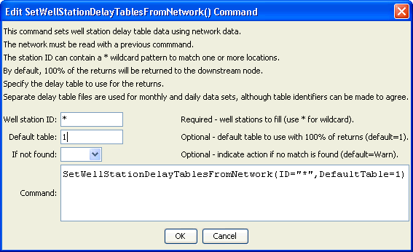
SetWellStationDelayTablesFromNetwork
SetWellStationDelayTablesFromNetwork() Command Editor

The command syntax is as follows:

SetWellStationDelayTablesFromNetwork(Parameter=Value,…)

Command Parameters

Parameter | Description | Default
ID | A single well station identifier to match or a pattern using wildcards (e.g., 20*). | None – must be specified.
DefaultTable | The default delay table to use when assigning the delay tables. | 1
IfNotFound | Used for error handling, one of the following:  - Fail – generate a failure message if the ID is not matched  - Ignore – ignore (don’t add and don’t generate a message) if the ID is not matched  - Warn – generate a warning message if the ID is not matched | Warn

