Command Reference: SetWellStationDepletionTablesFromRTN()

Set well station depletion table data from an RTN format file

StateMod Command
Version 3.09.01, 2010-02-01

The SetWellStationDepletionTableFromRTN() command sets depletion table data in existing well stations using information in an RTN format file, which is a format that has been used in CDSS StateMod modeling. The following dialog is used to edit the command and illustrates the syntax of the command.

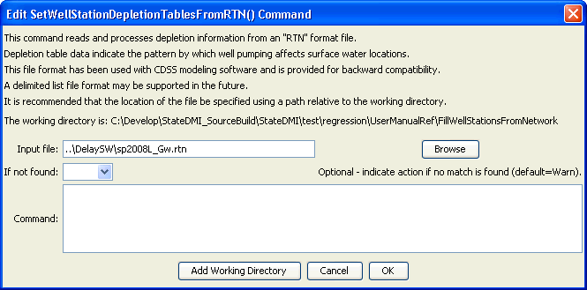
SetWellStationDepletionTablesFromRTN
SetWellStationDepletionTablesFromRTN() Command Editor

The command syntax is as follows:

SetWellStationDepletionTablesFromRTN(Parameter=Value,…)

Command Parameters

Parameter | Description | Default
InputFile | The name of the RTN file to process. Specify an absolute path or a path relative to the working directory. | None – must be specified.
IfNotFound | Used for error handling, one of the following:  - Fail – generate a failure message if the ID is not matched  - Ignore – ignore (don’t add and don’t generate a message) if the ID is not matched  - Warn – generate a warning message if the ID is not matched | Warn

A sample RTN file is shown below:

200511 2 0 1
200742 0 1
200742 100 2
200742 2 0 1
200787 0 1
200787 100 2
200752 2 0 1
20ADW07 0 1
20ADW07 100 2

The first line contains the station identifier, number of depletion locations, default efficiency for the station (unused – included because file format is the same as the return flow file), and the default delay table to use for the depletion. For the number of depletion locations, the following lines indicate the identifier for the station to receive the depletion, the percentage of the depletion to receive, and the delay table for the depletion.

