Command Reference: SetWellSystem()

Set well system parts

StateCU and StateMod Command
Version 3.09.00, 2010-01-21

The SetWellSystem() command sets well system part identifier data for a well (a CU Location that corresponds to a location with well supply, or StateMod well station). Well systems are specified using a list of part identifiers as follows:

- Part type is Ditch – the collection includes wells that are associated with a list of ditches, identified using ditch water district identifiers (WDIDs). The list of ditches is used for the full period.
- Part type is Parcel – the collection includes wells that are associated with a list of parcels. The division and year must be specified in the command because well to parcel relationships are determined for specific years.
- Part type is Well – the collection includes wells identified by well WDID (permit receipt number is not supported).

To facilitate processing, it is often best to use list files to specific aggregates (see SetWellSystemFromList()). Systems by convention have their water rights fully represented in output – to aggregate water rights at a location, use an aggregate (see the similar Aggregate commands). See also the StateDMI Introduction chapter, which provides additional information about aggregates and other modeling conventions. System information should be specified after well locations are defined and before their use in other processing, such as reading data from HydroBase.

The following dialog is used to edit the command and illustrates the syntax of the command.

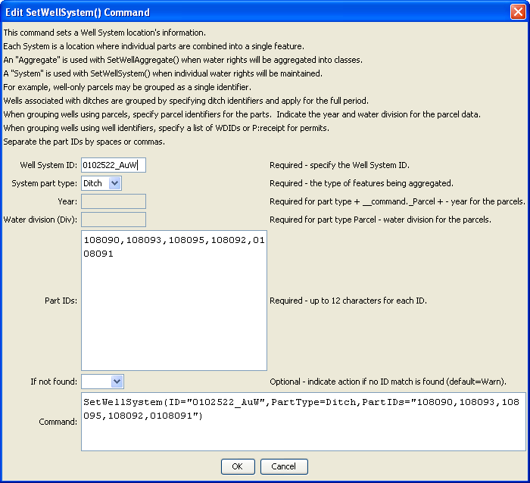
SetWellSystem
SetWellSystem() Command Editor

The command syntax is as follows:

SetWellSystem (Parameter=Value,…)

Command Parameters

Parameter | Description | Default
ID | The well identifier to associate with the collection of individual wells. | None – must be specified.
PartType | Indicate the type of features being aggregated and specified by PartIDs, one of:  - Ditch – the PartIDs (ditch WDIDs) indicate ditch service areas supplemented by wells.  - Parcel – the PartIDs (parcel numbers from GIS processing) indicate parcels irrigated by wells, with no surface water supply.  - Well – the PartIDs indicate wells (WDIDs), with no surface water supply. | None – must be specified.
Year | The year defining the parcels. | Required when PartType is Parcel because parcel identifiers from well matching are specific to the data year.
Div | Water division for the parcels in the system. | Required when PartType is Parcel because parcels require the division.
PartIDs | The list of part identifiers to comprise the system. | None – must be specified.
IfNotFound | Used for error handling, one of the following:  - Fail – generate a failure message if the identifier is not matched  - Ignore – ignore (don’t add and don’t generate a message) if the identifier is not matched  - Warn – generate a warning message if the identifier is not matched | Warn

This page is intentionally blank.

