Command Reference: SetWellSystemFromList()

Set well system parts from data in a list file

StateCU and StateMod Command
Version 3.09.00, 2010-01-21

The SetWellSystemFromList() command sets well system part identifier data for a well (a CU Location that corresponds to a location with well supply, or StateMod well station). Well systems are specified using a list of part identifiers as follows:

- Part type is Ditch – the collection includes wells that are associated with a list of ditches, identified using ditch water district identifiers (WDIDs). The list of ditches is used for the full period.
- Part type is Parcel – the collection includes wells that are associated with a list of parcels. The division and year must be specified in the command because well to parcel relationships are determined for specific years.
- Part type is Well – the collection includes wells identified by well WDID (permit receipt number is not supported).

To facilitate processing, the list of parts is specified in a delimited list file. Systems by convention have their water rights fully represented in output – to aggregate water rights at a location, use an aggregate (see the similar Aggregate commands). See also the StateDMI Introduction chapter, which provides additional information about systems and other modeling conventions. System information should be specified after well locations are defined and before their use in other processing, such as reading data from HydroBase.

The following dialog is used to edit the command and illustrates the syntax of the command.

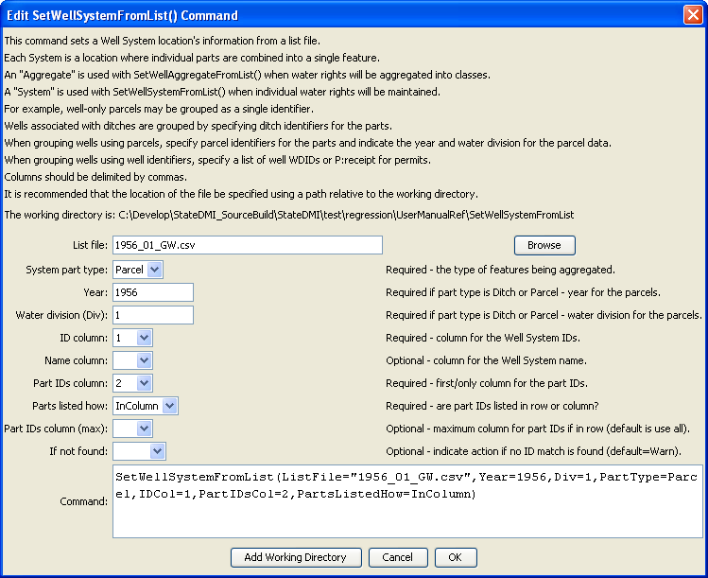
SetWellSystemFromList
SetWellSystemFromList() Command Editor

The command syntax is as follows:

SetWellSystemFromList(Parameter=Value,…)

Command Parameters

Parameter | Description | Default
ListFile | The name of the input file to read, surrounded by double quotes. | None – must be specified.
PartType | Indicate the type of features being aggregated and specified by PartIDs, one of:  - Ditch – the PartIDs (ditch WDIDs) indicate ditch service areas supplemented by wells.  - Parcel – the PartIDs (parcel numbers from GIS processing) indicate parcels irrigated by wells, with no surface water supply.  - Well – the PartIDs indicate wells (WDIDs), with no surface water supply. | None – must be specified.
Year | The year defining the parcels. | Required when PartType is Parcel because parcel identifiers from well matching are specific to the data year.
Div | Water division for the parcels in the system. | Required when PartType is Parcel because parcels require the division.
IDCol | The column number (1+) containing the well system identifiers. | None – must be specified.
NameCol | The column number (1+) containing the well system name. | None – optional (name will remain as before).
PartIDsCol | The column number (1+) for the first column having part identifiers. | None – must be specified.
PartsListedHow | If InRow, it is expected that all parts defining a system are listed in the same row. If InColumn, it is expected that the parts defining a system are listed one per row, with multiple rows defining the full system (PartIDsColMax is ignored in this case). | None – must be specified.
PartIDsColMax | The column number (1+) for the last column having part identifiers. Use if extra columns on the right need to be excluded from the list. | Use all available non-blank columns starting with PartIDsCol.
IfNotFound | Used for error handling, one of the following:  - Fail – generate a failure message if the aggregate identifier is not matched  - Ignore – ignore (don’t add and don’t generate a message) if the aggregate identifier is not matched  - Warn – generate a warning message if the aggregate identifier is not matched | Warn

The following example illustrates a list file is used with PartType=Parcel and PartsListedHow=InColumn:

"UZONES","PARCEL"
20URF0,16831
20URF0,16832
20URF0,16834
…
20URF0,18606
20URF24,10295
20URF24,10318
…

The following example illustrates a list file is used with PartType=Ditch and PartsListedHow=InColumn, with the name being provided in column 2:

# System_ID/Agg_Name/WDID
01_ADP037,South Platte River below Kersey Co North 2,0100643
01_ADP037,South Platte River below Kersey Co North 2,0100644
01_ADP037,South Platte River below Kersey Co North 2,0100835
01_ADP037,South Platte River below Kersey Co North 2,0104486

