Command Reference: SortBlaneyCriddle()

Sort Blaney-Criddle data

StateCU Command
Version 03.08.02, 2010-01-07

The SortBlaneyCriddle() command sorts the Blaney-Criddle crop coefficients using the crop name.

The following dialog is used to edit the command and illustrates the syntax of the command.

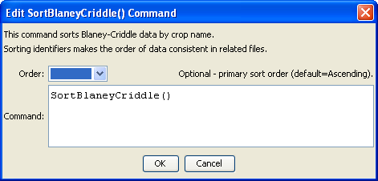
SortBlaneyCriddle
SortBlaneyCriddle() Command Editor

The command syntax is as follows:

SortBlaneyCriddle(Parameter=Value,…)

Command Parameters

Parameter | Description | Default
Order | Indicate the order for the sort for the crop name. Currently only Ascending is supported. The older Alphabetical will be converted automatically. | Ascending

