Command Reference: SortCULocations()

Sort CU Locations

StateCU Command
Version 3.09.00, 2010-01-10

The SortCULocations() command sorts the CU Locations.

The following dialog is used to edit the command and illustrates the syntax of the command.

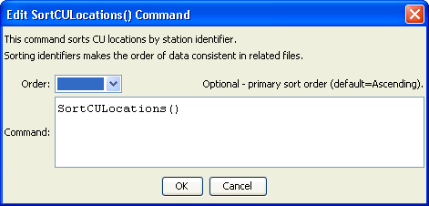
SortCULocations
SortCULocations() Command Editor

The command syntax is as follows:

SortCULocations(Parameter=Value,…)

Command Parameters

Parameter | Description | Default
Order | Indicate the sort order for identifiers. Currently only Ascending is supported. The older Alphabetical is automatically converted to Ascending. | Ascending

