Command Reference: SortClimateStations()

Sort climate stations

StateCU Command
Version 3.08.02, 2010-01-05

The SortClimateStations() command sorts the climate stations using the station identifiers.

The following dialog is used to edit the command and illustrates the syntax of the command.

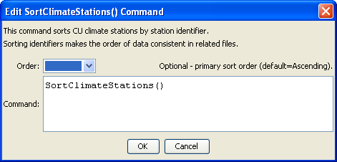
SortClimateStations
SortClimateStations() Command Editor

The command syntax is as follows:

SortClimateStations(Parameter=Value,…)

Command Parameters

Parameter | Description | Default
Order | Indicate the sort order. Currently only Ascending is supported. | Ascending

The following example command file illustrates how climate stations can be defined, sorted, and written to a StateCU file:

ReadClimateStationsFromList(ListFile="climsta.lst",IDCol=1)
FillClimateStationsFromHydroBase(ID="*")
SetClimateStation(ID="3016",Region2="14080106",IfNotFound=Warn)
SetClimateStation(ID="1018",Region2="14040106",IfNotFound=Warn)
SetClimateStation(ID="1928",Elevation=6440,IfNotFound=Warn)
SetClimateStation(ID="0484",Region1="MOFFAT",IfNotFound=Add)
SortClimateStations()
WriteClimateStationsToStateCU(OutputFile="COclim2006.cli")

