Command Reference: SortCropCharacteristics()

Sort crop characteristics

StateCU Command
Version 3.08.02, 2010-01-07

The SortCropCharacteristics() command sorts the crop characteristics using the crop name, and is typically used before writing output.

The following dialog is used to edit the command and illustrates the syntax of the command.

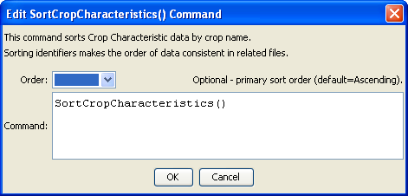
SortCropCharacteristics
SortCropCharacteristics() Command Editor

The command syntax is as follows:

SortCropCharacteristics(Parameter=Value,…)

Command Parameters

Parameter | Description | Default
Order | Indicate the order for the sort for the crop name. Currently only Ascending is supported. The older Alphabetical will be converted automatically. | Ascending

