Command Reference: SortCropPatternTS()

Sort crop pattern time series

StateCU Command
Version 3.09.01, 2010-02-01

The SortCropPatternTS() command sorts the crop pattern time series using the location identifier, and is typically used before writing output.

The following dialog is used to edit the command and illustrates the syntax of the command.

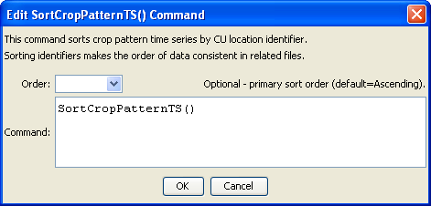
SortCropPatternTS
SortCropPatternTS() Command Editor

The command syntax is as follows:

SortCropPatternTS(Parameter=Value,…)

Command Parameters

Parameter | Description | Default
Order | Indicate the order for the sort. Currently only Ascending is supported. The older Alphabetical will be converted automatically. | Ascending

