Command Reference: SortDiversionHistoricalTSMonthly()

Sort diversion historical time series (monthly)

StateMod Command
Version 3.09.01, 2010-02-01

The SortDiversionHistoricalTSMonthly() command sorts the diversion historical time series (monthly) in alphabetical order, using the time series identifier (typically by the location since the location will vary between time series). This command is useful if time series have been added during processing and therefore the time series order no longer agrees with the diversion station order.

The following dialog is used to edit the command and illustrates the syntax of the command.

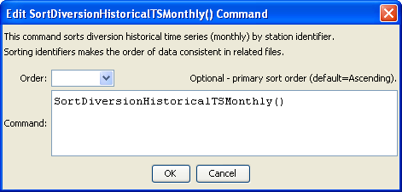
SortDiversionHistoricalTSMonthly
SortDiversionHistoricalTSMonthly() Command Editor

The command syntax is as follows:

SortDiversionHistoricalTSMonthly(Parameter=Value,…)

Command Parameters

Parameter | Description | Default
Order | Indicate the order for the sort. Currently only Ascending is supported. The older Alphabetical is automatically converted to Ascending. | Ascending

